Introduction to Dashboards and Alerts

The Splunk platform provides a rich eco-system for developing visualizations and dashboards. Using dashboards, you can readily display useful information that can be used by different types of audiences. For example, you can create a dashboard for a NOC (Network Operations Center) that displays a service's health. You can make another dashboard for the software development team that displays the application resource utilization, such as CPU and Memory. Using the Dashboard editor, you can easily put together relevant visualizations as panels in a dashboard within minutes. In addition, the dashboard can be made interactive by providing users a form to provide input. For example, a user can choose an option from a drop-down list. Further, the dashboard can contain drill-down actions that can, among other things, take a user to another dashboard or an external site.

Using the Splunk platform you can also create Alerts. Alerts are saved searches with a threshold component attached to it. When a threshold is breached, you can have Splunk trigger an action, such as emailing someone or paging the on-call engineer. For example, you can set up an alert to page the on-call engineer if a service becomes unavailable. In addition to emailing and paging, you can use Splunk to trigger varieties of actions, such as posting the alert data to an external website or posting a message in a chat room. You can also create your own custom action by using Splunk's custom action framework.

Let us begin by creating a basic dashboard in the next section.

# Creating a Basic Dashboard

We will use Splunk's tutorial data for creating a dashboard. You can download the Splunk tutorial data from the following link:

<https://docs.splunk.com/Documentation/Splunk/latest/SearchTutorial/Systemrequirements#Download_the_tutorial_data_files>

Download tutorialdata.zip and Prices.csv.zip to your local drive. Upload them to your Splunk instance. For detailed instructions on uploading the turorialdata.zip, refer to Introduction to the Splunk Platform chapter from the book. For detailed instructions on uploading the Prices.csv.zip, refer to the Using Lookups chapter from the book.

We will start by creating a basic dashboard and add functionality throughout this chapter. Let's start by building a web server health dashboard. We'll call our fictious company Acme Corp.

## Adding the First Panel

A dashboard is made up of panels that display information. More specifically. they display search results. The simplest way to add a panel to a dashboard is to first write the SPL query, and simply add the results to a dashboard panel. Let's start by writing the SPL.

index=main sourcetype=access_combined_wcookie

| timechart span=1h count AS Total_Requests, count(eval(status LIKE "5%")) AS Server_Errors

The SPL query plots a timechart of total number of requests coming into the web server and the number of requests failing with 500 series HTTP codes. First, it filters the retrieved data by the sourcetype (access_combined_wcookie). It then uses timechart command with a span of 1 hour to calculate the total number of requests within that span, and the number of requests where the status is 5 followed by any characters (5%). This will match status like 500,501,502 and so on. Make sure to set the time picker to All Time.

The result will be as shown in figure 10-1.

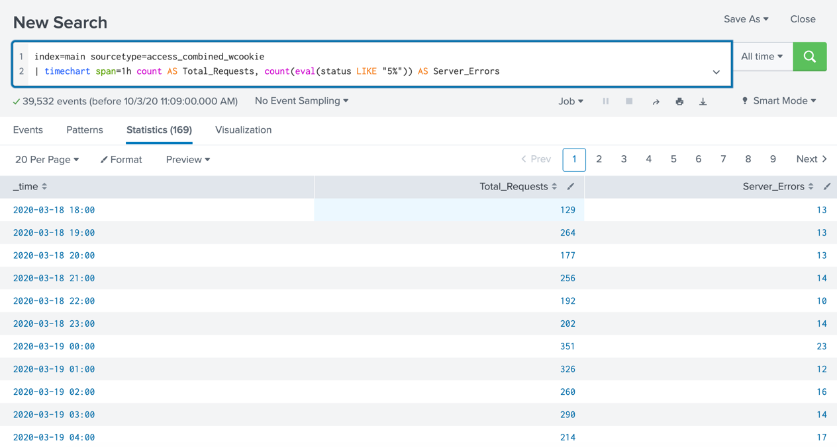

*Figure 10-1. Running a search before adding to a dashboard*

Navigate to the Visualization tab to reveal the graph that Splunk has come up with. In the visualization tab, you can choose the type of visualization you like. For example, you may choose an area chart instead of a line chart. See figure 10-2.

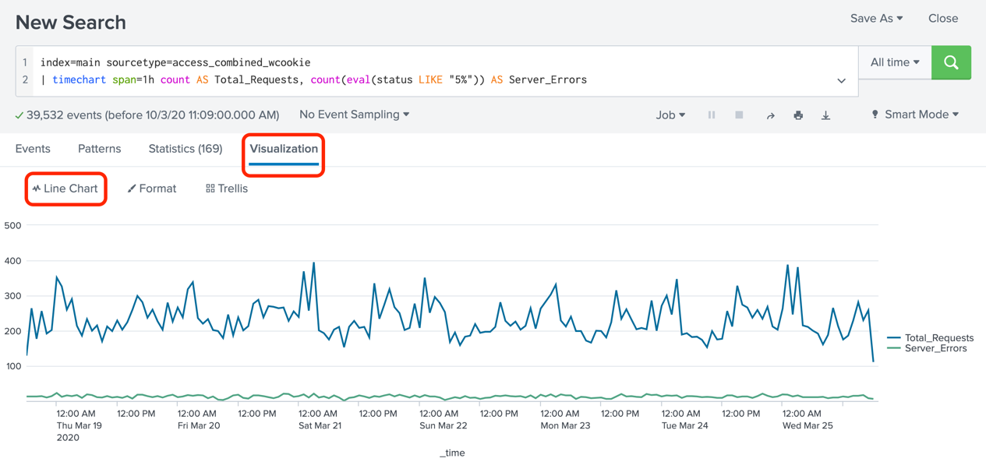

*Figure 10-2. Choosing the visualization type*

Also, based on the visualization you choose, you can configure varieties of formatting options. For example, you can choose a custom X axis title instead of the default _time. See figure 10-3.

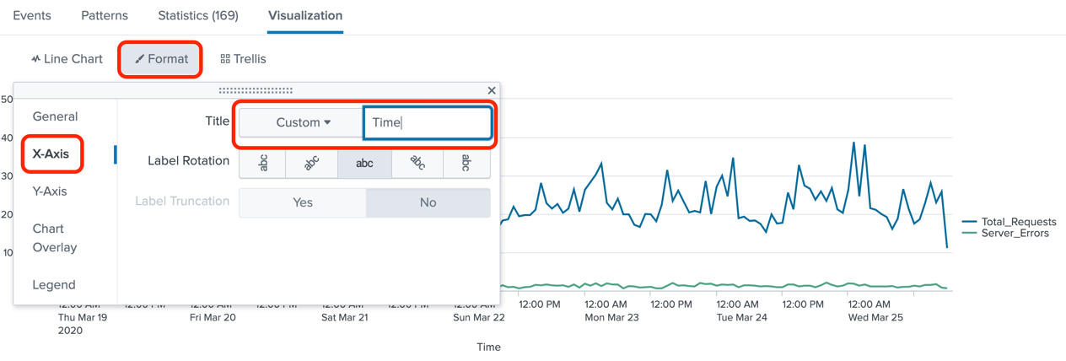

*Figure 10-3. Customizing formatting options of a visualization*

Once you have the visualization displayed the way you want, in order to save this visualization as a dashboard panel, select Save As at the top right and select Dashboard Panel. See figure 10-4.

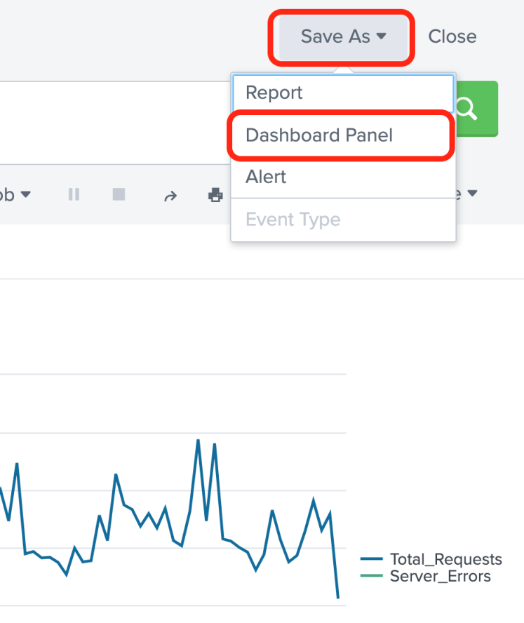

*Figure 10-4. Saving a visualization as a dashboard panel*

In the resulting Save As Dashboard Panel screen, enter the following details:

Dashboard: New

Dashboard Title: Acme Corp Web Server Health

Description: Acme Corp's Web server statistics dashboard

Panel Title: Web Server Traffic Over Time

Panel Content: Line Chart

Click Save.

See figure 10-5.

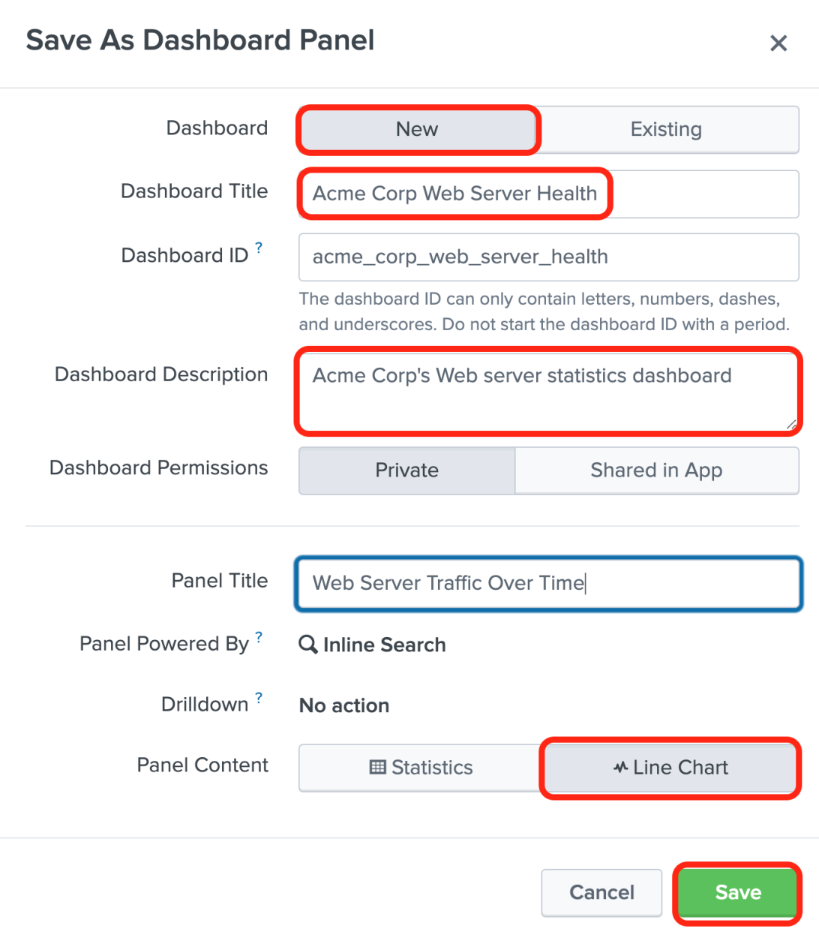

*Figure 10-5. Saving a visualization as a dashboard panel*

**Tip** By default, the dashboard gets created with Private permission. If you need to grant access to other users of Splunk, select Shared in App. You can also change the permissions at any time after you create the dashboard.

After you click Save, you can view the dashboard by clicking View Dashboard on the resulting screen. See figure 10-6.

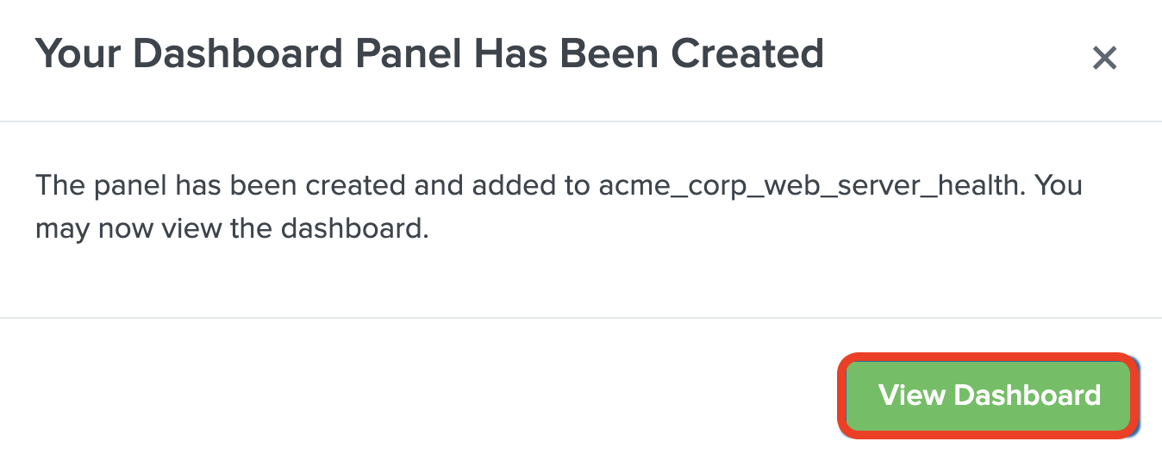

*Figure 10-6. Notification of successful creation of the dashboard panel*

Congratulations. You have just created a dashboard. Upon clicking on View Dashboard, you will be taken to the dashboard. See figure 10-7.

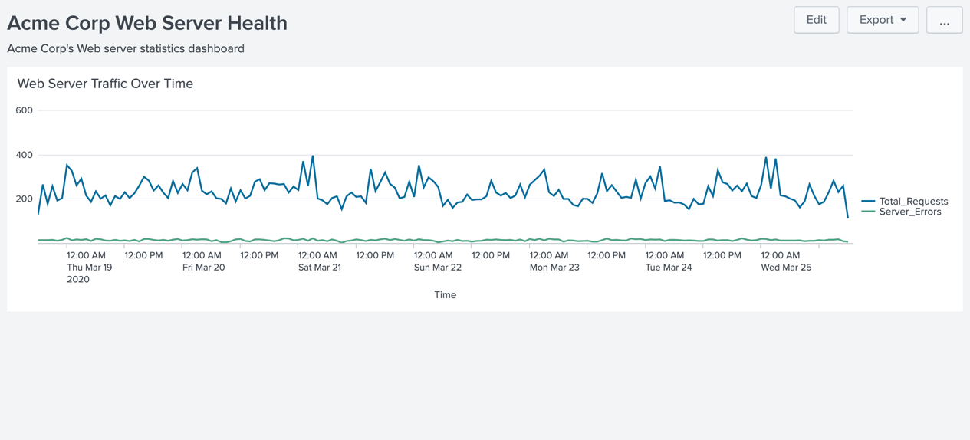

*Figure 10-7. A newly created dashboard with one panel*

Let us continue building our dashboard by adding two more panels. First, we'll add a timechart that shows the average and 95th percentile response times. The response time of a request is logged as the last field in an access log event. In Splunk's tutorial data that we are using, this field is extracted with the name other. In the event below, the highlighted field is the response time in milliseconds (159).

91.205.189.15 - - [25/Mar/2020:18:22:16] "GET /oldlink?itemId=EST-14&JSESSIONID=SD6SL7FF7ADFF53113 HTTP 1.1" 200 1665 "http://www.buttercupgames.com/oldlink?itemId=EST-14" "Mozilla/5.0 (Windows NT 6.1; WOW64) AppleWebKit/536.5 (KHTML, like Gecko) Chrome/19.0.1084.46 Safari/536.5" **159**

Let us first build our SPL query.

index=main sourcetype=access_combined_wcookie

| timechart span=1h avg(other) AS Average_Response_Time, perc95(other) AS 95th_Precentile_Response_Time

The line chart visualization of the result of the SPL is shown in in figure 10-8.

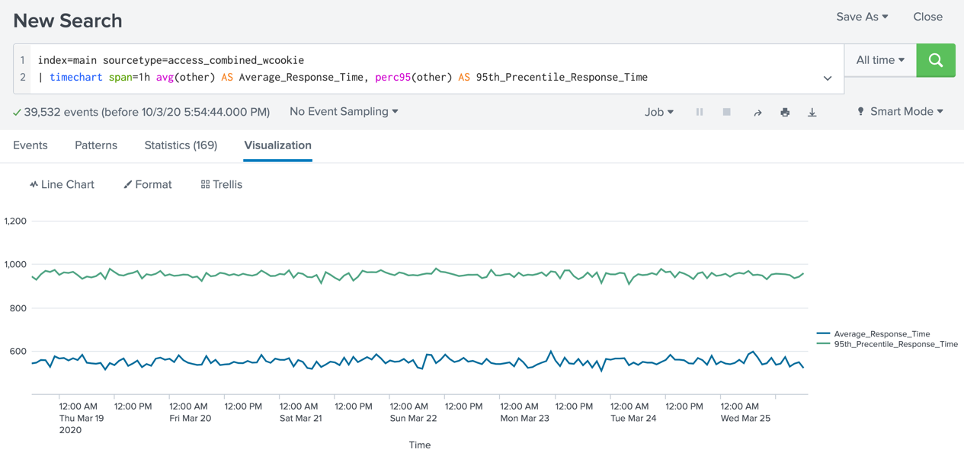

*Figure 10-8. A timechart showing the response times using the web access log*

Add the visualization to the dashboard, by clicking on Save As > Dashboard Panel. This time choose Existing dashboard by selecting Acme Corp Web Server Health. Provide a panel title and click Save. See figure 10-9.

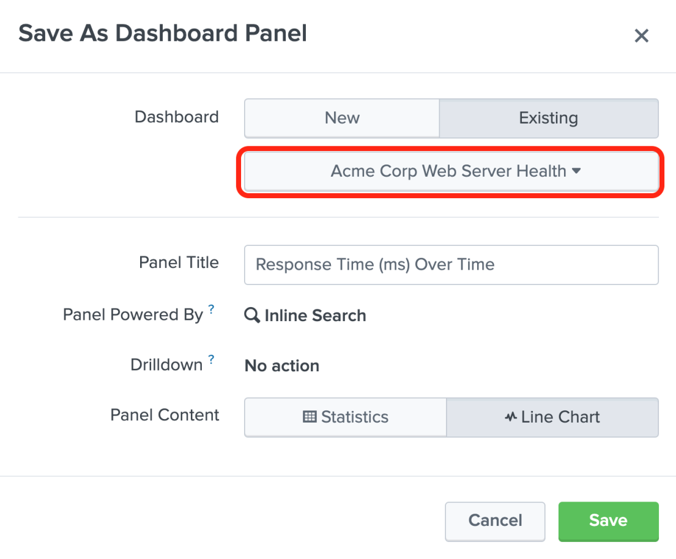

*Figure 10-9. Choosing an existing dashboard to add panels*

Let us add another panel that shows the breakdown of HTTP status codes. We'll use a pie chart this time. Here is the SPL query:

index=main sourcetype=access_combined_wcookie

| stats count by status

The SPL simply uses the stats command to break down a count of the events by status. After the search completes, choose Pie chart from the visualization, and save the visualization to the same dashboard (Acme Corp Web Server Health). Use the panel title HTTP Status Code Breakdown. See Figure 10-10.

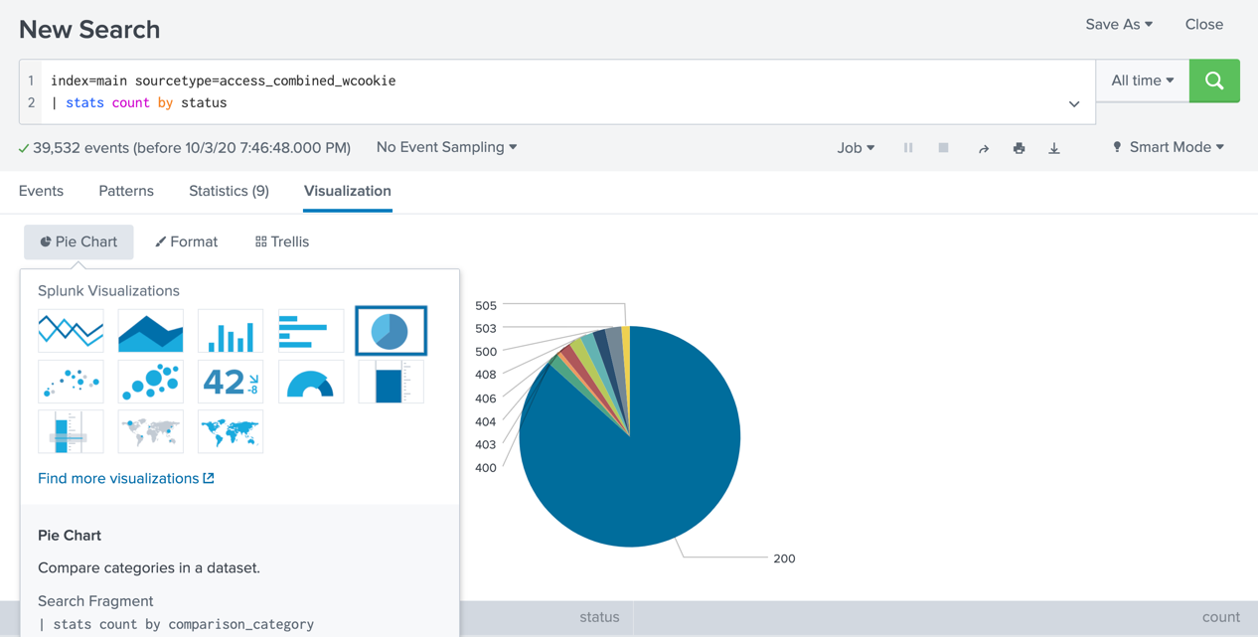

*Figure 10-10. Selecting Pie Chart as visualization.*

Our now dashboard now has three panels and looks like figure 10-11.

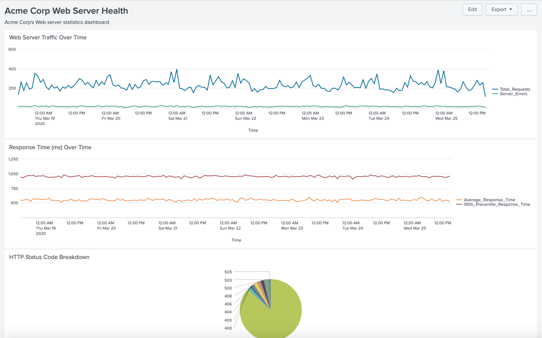

*Figure 10-11. Web Server health dashboard with 3 panels.*

**Tip** You can always launch the dashboard by navigating to Dashboards menu in the App bar.

Our dashboard is shaping up nicely. But you may have noticed that the panels stack up in a row, one underneath the other. This is the default behavior. You can edit the dashboard by dragging them to different positions. For example, you can drag the pie chart to be at the same level as the Response time line chart. In order to do this, click on the Edit button at the top right. See Figure 10-12.

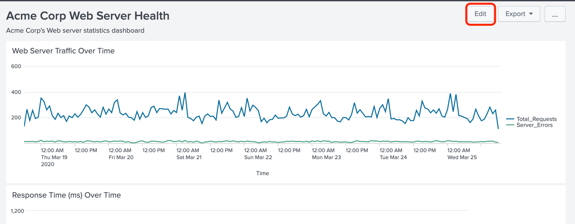

*Figure 10-12. Launching the Edit interface of a dashboard.*

Once in the edit interface, you can drag a panel using its handle (denoted by the two dotted lines at the top of the panel). See figure 10-13.

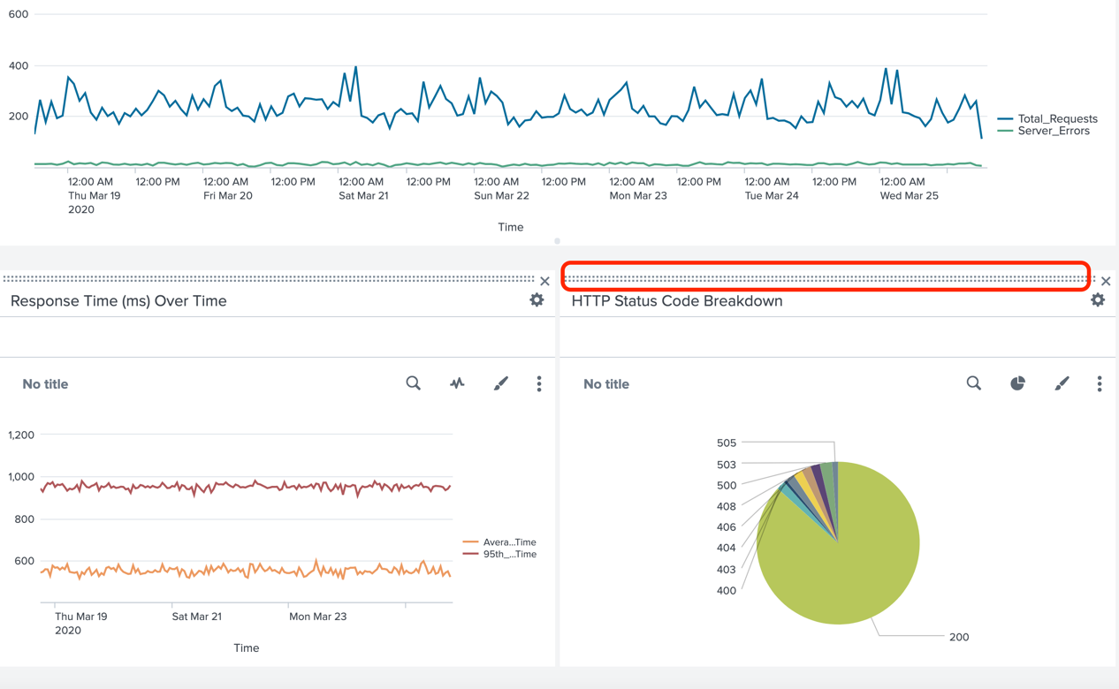

*Figure 10-13. Re positioning panels in a dashboard*

Make sure you save the dashboard by clicking on the Save button at the top right. The completed dashboard now looks like figure 10-14.

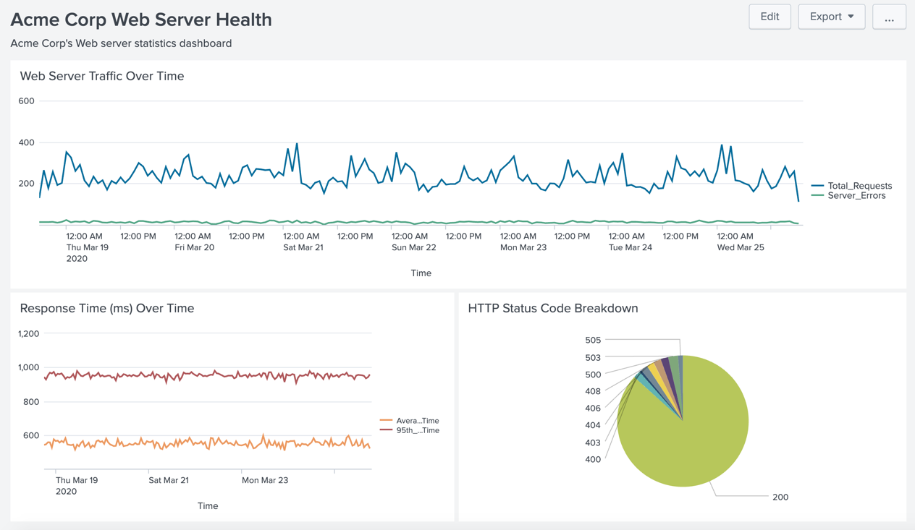

*Figure 10-14. A complete basic dashboard*

You have just created a basic dashboard and performed some minimal editing as well. Great job! In the next section, let's look at various ways of adding data to the panels.

# Generating Dashboard Content

We saw how the search results can be used to create panels in a dashboard. Using search results is one of the basic ways to add content to a dashboard. The panels created by using search results in this manner use inline searches. There are other ways to power a dashboard panel. These ways are mentioned below:

1. Using saved searches (reports)
2. Using prebuilt panels
3. Using Pivots
4. Using global base searches.

I will briefly discuss each of these methods.

## Using Saved Searches (Reports)

Instead of using inline searches, you can create a panel using a saved search. Saved searches are also known as reports. If the reports are scheduled, the panel will display the results from the latest run of the report. Using scheduled searches to power the panels is one of the best ways of improving dashboard performance. This is because the dashboard simply loads the results from the last run of the scheduled search, instead of re-running the search. You can add a report as dashboard panel by using Add Panel and choosing an available report. See figure 10-15.

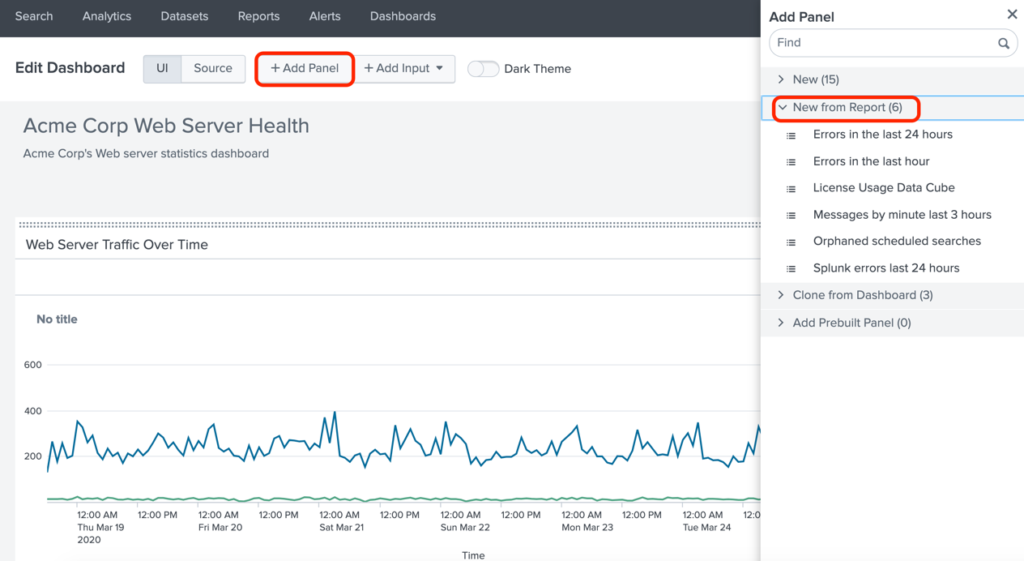

*Figure 10-15. Using reports to add contents to dashboard panel*

You can also add a report to a dashboard panel from the report. Simply click on Add to Dashboard button at the top right.

**Caution** Reports can be configured to run as either owner or the user who is running the report. Scheduled reports always run as owner. When a dashboard is loaded that has panels backed by reports, the concurrent search limit of the owner will be impacted.

## Using Prebuilt Panels

An inline panel can be converted to a pre-built panel. A pre-built panel can be used in any other dashboard to quickly add visualizations to that dashboard. To convert an inline panel to pre-built panel, simply edit the dashboard and use the menu Convert to Prebuilt Panel in the panel edit menu (click on the gear icon to bring up the panel edit menu). See figure 10-16.

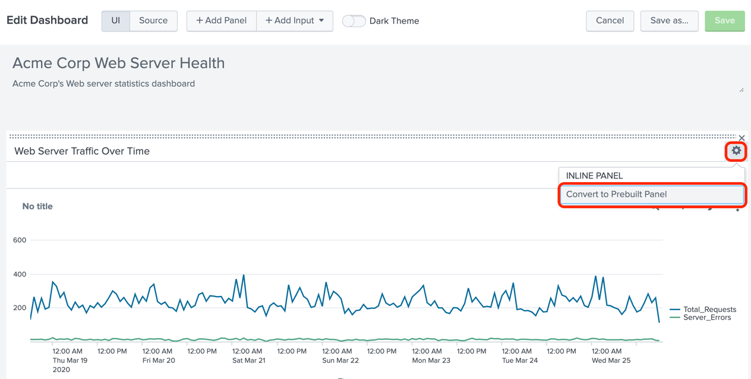

*Figure 10-16. Converting an inline panel to prebuilt panel*

To use a prebuilt panel in a dashboard, simply use the Add panels menu and choose from the available prebuilt panels. See figure 10-17.

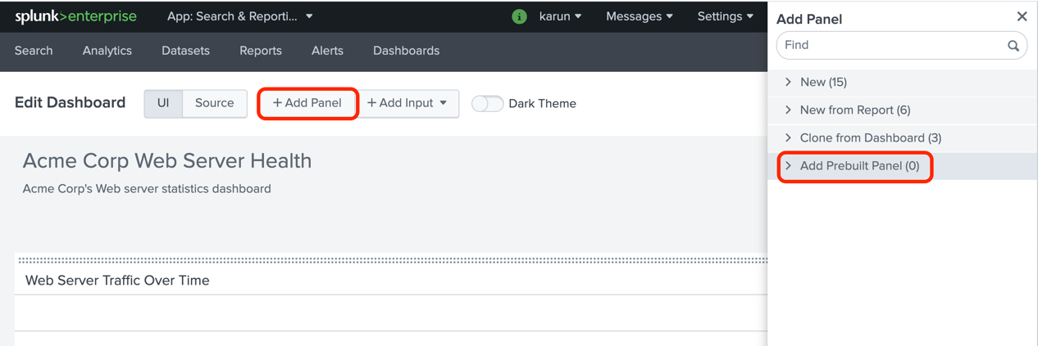

*Figure 10-17. Adding a prebuilt panel to a dashboard*

**Note** Only the available pre-built panels are shown under Add Prebuilt Panel menu

## Using Pivots

A pivot refers to a visualization such as a chart or table that you create using Pivot Editor. Pivots are used as a quick way to create visualizations using data models without having to write SPL queries. See figure 10-18.

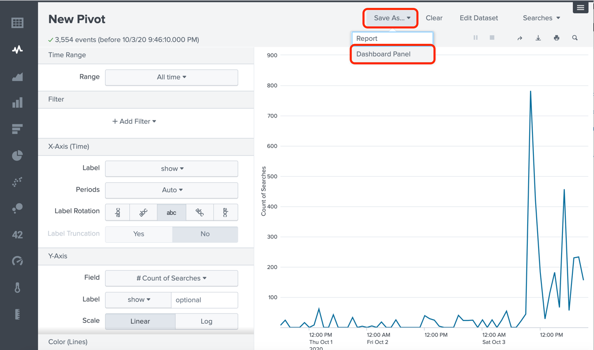

*Figure 10-18. Adding a pivot to a dashboard*

We will not discuss Pivots in detail in this book as it is beyond the scope.

## Using Global Base Searches

You can define a SPL query as global base search within a dashboard. Using the results of the base search, you can populate other panels within the dashboard with any desired post-processing. This is especially useful if you have a dashboard with many panels performing similar searches. You can save resources by defining a base search and having the panels in the dashboard use a post-process search to further modify the search results.

You would define the base search using a search id and reference that search id in the child panels using the base attribute.

In the next section, let's add interactivity to your dashboards by introducing input controls.

# Using Forms to Process User Input

You can make your dashboards interactive by adding input panels in a form. For example, you can have the user choose the time frame for the searches in the dashboard panels. As another example, you can allow the user to select an option from a list of options in a drop-down box. You can configure dashboard panels to respond to the user input. The Splunk platform achieves this by the use of tokens.

Tokens are similar to variables in high-level programming languages. They can be set to a value based on a user action and retrieved by dashboard panels. We will consider two examples in this section. First, we'll add a time input to allow the user to choose a time frame. Next, we'll add a drop-down list to allow the user to choose an option.

## Adding Time Input

For this example, let's create a new dashboard. Using Splunk tutorial data and prices.csv lookup table, we'll create a Business Analytics dashboard. First, we'll display a single value visualization that shows the total revenue in dollars. The total revenue is obtained by summing the sale price of all purchased products. We can derive this by the following SPL query:

index=main sourcetype=access_combined_wcookie action=purchase

| lookup prices.csv productId OUTPUTNEW sale_price

| stats sum(sale_price) AS total

| eval Total_Revenue = "$" . tostring(total,"commas")

| fields – total

The SPL query retrieves the events where action is purchase and looks up prices.csv to bring in the sale price. The stats command sums up the sale prices and the eval command prints the dollar amount using $ sign and commas for readability. The result is shown below:

Total_Revenue

-------------

$45,558.28

We'll add this result as a single value visualization in a new dashboard. First, display the result using single value visualization. See figure 10-19.

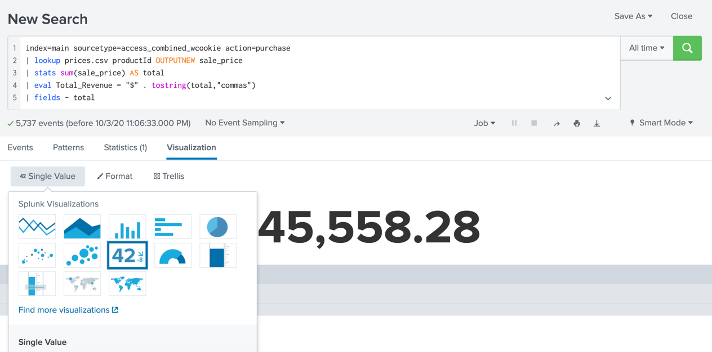

*Figure 10-19. Choosing Single Value visualization*

As before, select Save As > Dashboard Panel and create a new dashboard. See figure 10-20.

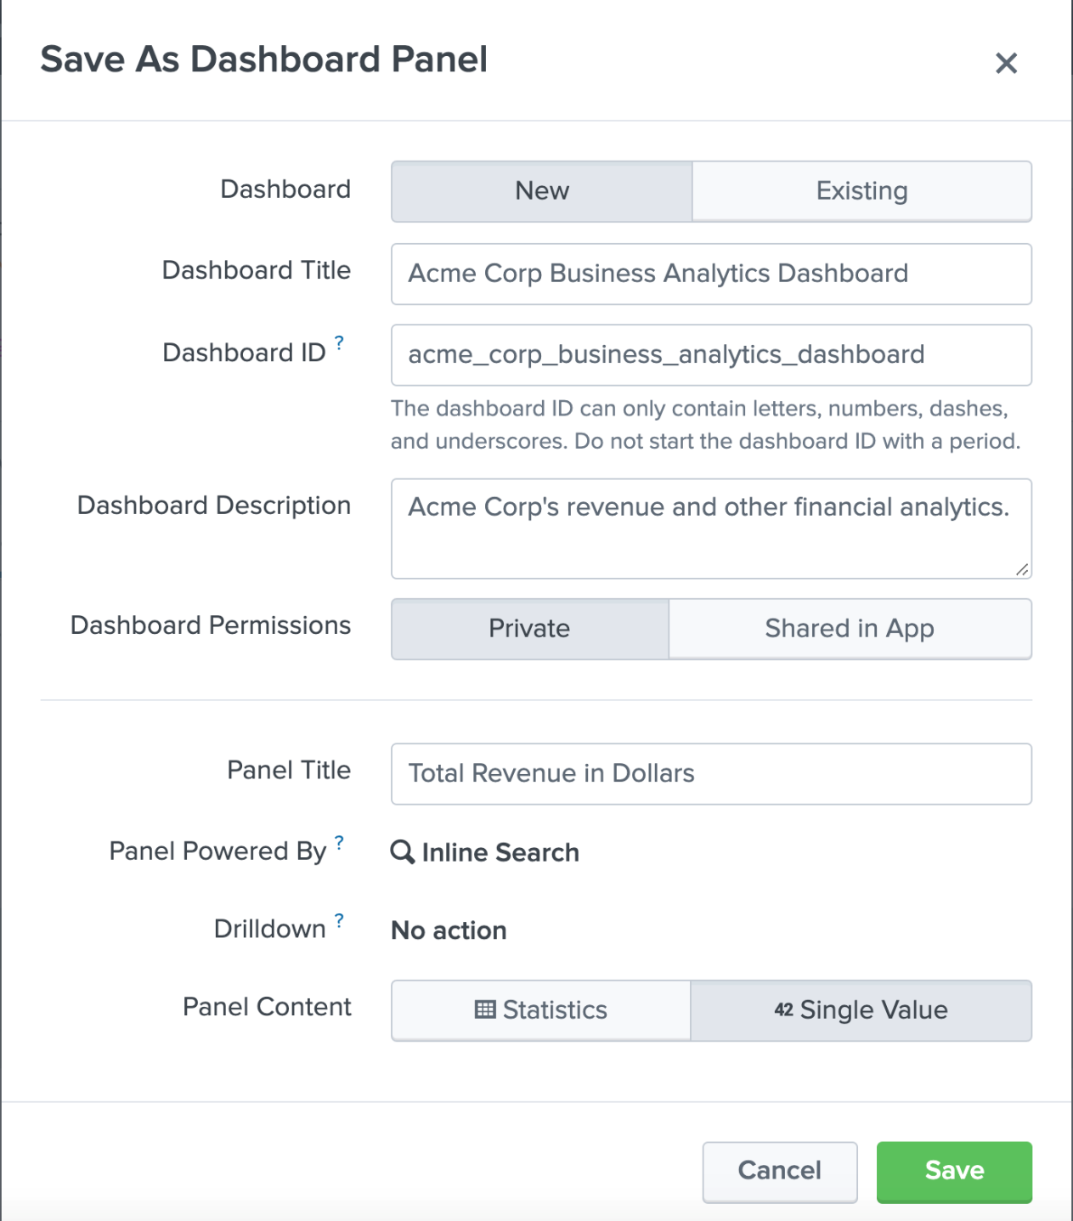

*Figure 10-20. Creating a new dashboard from single value visualization*

The dashboard is created and looks like figure 10-21.

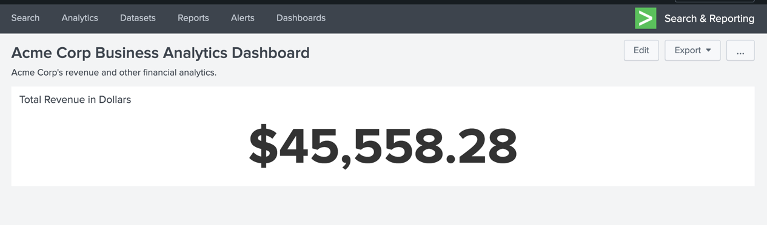

*Figure 10-21. Newly created dashboard with single value visualization.*

Let us enable dark theme by editing the dashboard and selecting the Dark Theme toggler at the top middle. You need to reload the dashboard for the change to take effect. The dashboard now looks like figure 10-22.

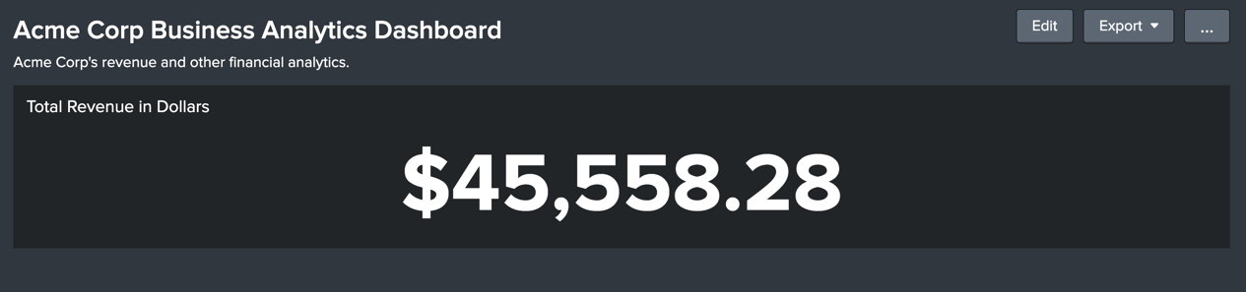

*Figure 10-22. Dashboard with dark theme*

Let us add another panel next to the Total Revenue panel. We will show the top 5 products based on the revenue. The SPL query is as follows:

index=main sourcetype=access_combined_wcookie action=purchase

| lookup prices.csv productId OUTPUTNEW product_name,sale_price

| stats sum(sale_price) AS Revenue by product_name

| sort 5 -Revenue

| eval Revenue = "$" . tostring(Revenue,"commas")

Splunk produces the following output:

product_name Revenue

------------------------------

Dream Crusher $5,647.74

Manganiello Bros. $5,572.77

World of Cheese $5,497.25

Mediocre Kingdoms $5,317.34

SIM Cubicle $4,638.27

Instead of choosing a visualization, simply use the table output in the statistics tab and save the table as dashboard panel. Choose the existing Acme Corp Business Analytics Dashboard. The dashboard now looks like figure 10-24

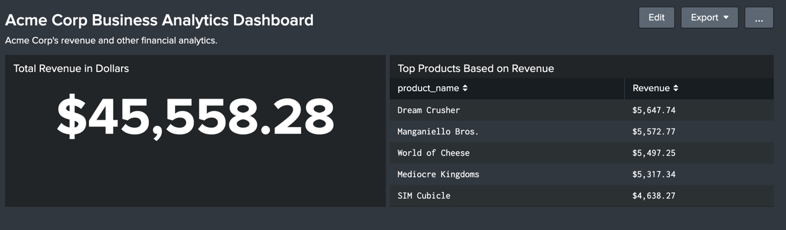

*Figure 10-23. Dashboard with two panels*

Now let us add the time picker input. This will let a user choose a time frame. Edit the dashboard and choose Add Input > Time. See figure 10-24.

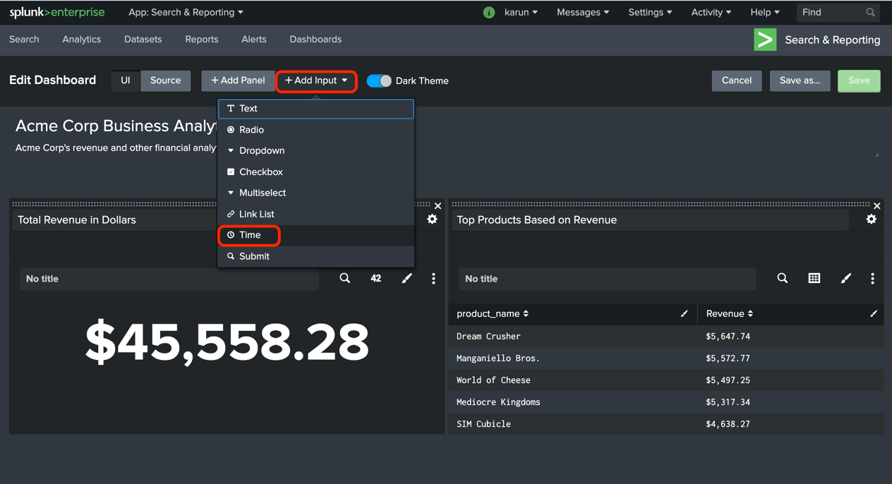

*Figure 10-24. Selecting Time Input*

A new Time Input panel is added to the top right. Click on the pencil icon at the top to edit the Time Input. Enter the following details:

Label: Select Time Range

Search on Change: Select the check box

Token: tok_time

Click Apply. See figure 10-25.

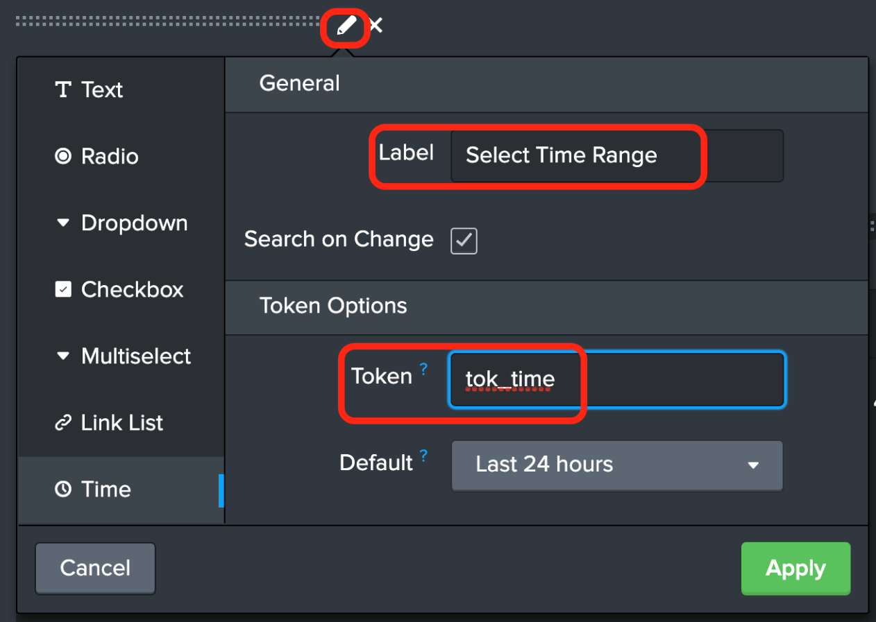

*Figure 10-25. Editing Time Input*

The Label is the text that the user sees in the user interface. Provide a meaningful name for this. The option Search on Change dynamically re-runs all the panels that use this Time Input when a time-range is selected. The Token is the id used to reference the selected time in searches that make use of this input. This is how we pass the value of the time the user selected to other panels in the search. To reference a token in a search, use $token_name$. For example, to refer to the Time selected by the user using this input, you will use $tok_time$.

**Tip** Always provide a meaningful name to the token so that it is easy to reference in searches. Avoid using unclear names such as field1.

Now that you've saved the Time Input, we'll need tie in this input to all the panels that make use of this Time. For this, we'll need to edit the search of each panel. While still in the Edit interface, click on the search icon of the Total Revenue in Dollars panel. See figure 10-26.

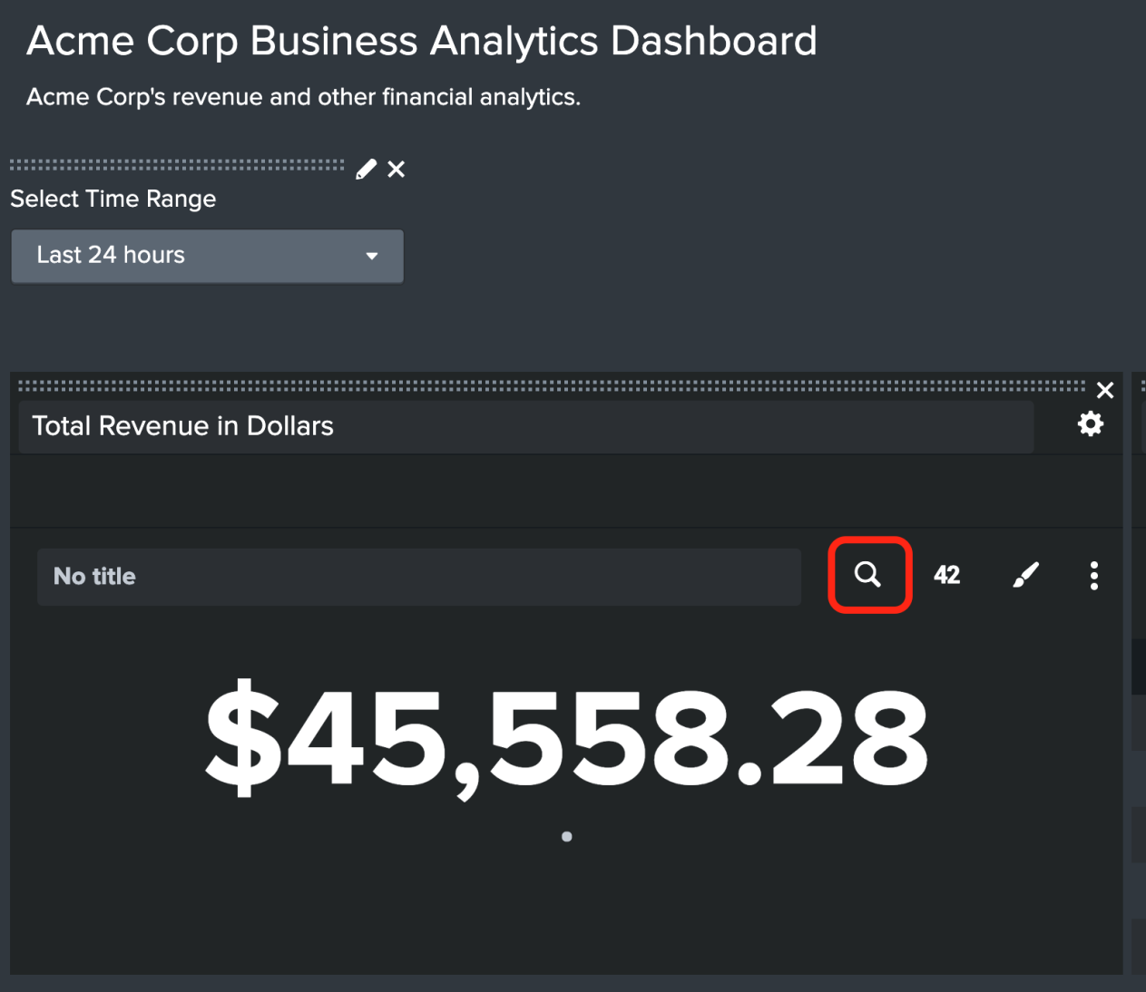

*Figure 10-26. Editing the search of a panel in the dashboard*

In the resulting Edit window, select Shared Time Picker (tok_time) for the Time Range. If you recall, this is the token name that we used in the Time Input. Click Apply. See figure 10-27.

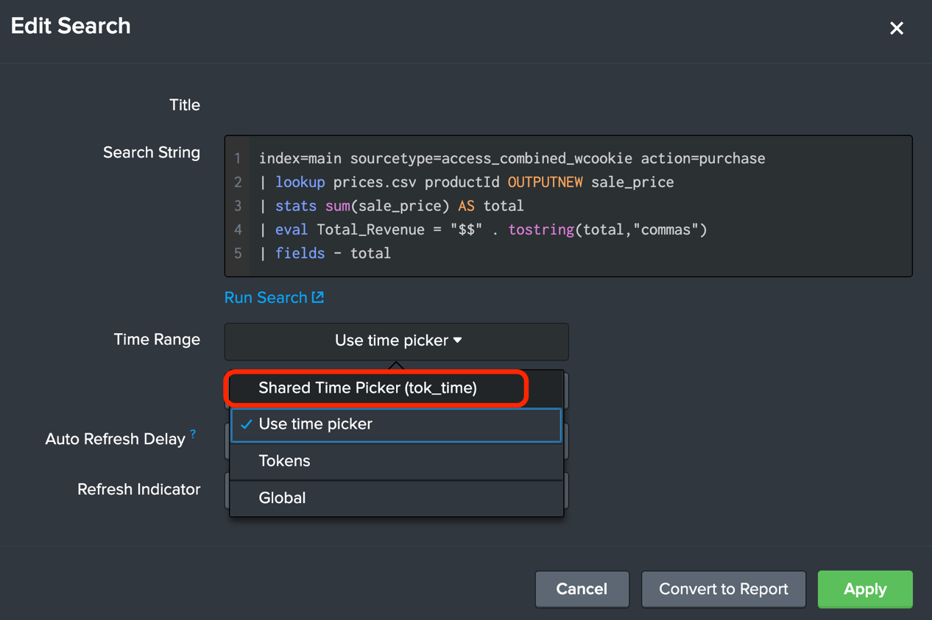

*Figure 10-27. Editing the search of a panel to update the Time Range*

Repeat the same process for the panel Top Products Based on Revenue. Click on Save at the top right to save the dashboard. Now, our dashboard looks like figure 10-28.

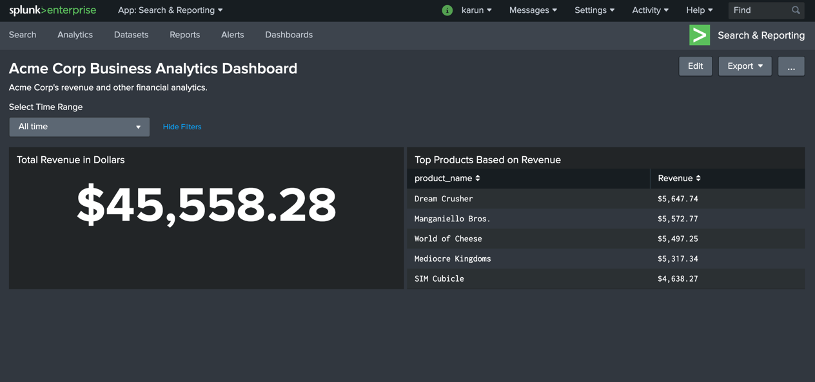

*Figure 10-28. Dashboard with Time Input*

From now onwards, you can choose the time frame you want for the panels to use. When you select a time range, the panels automatically reload the data for the time frame selected. See figure 10-28.

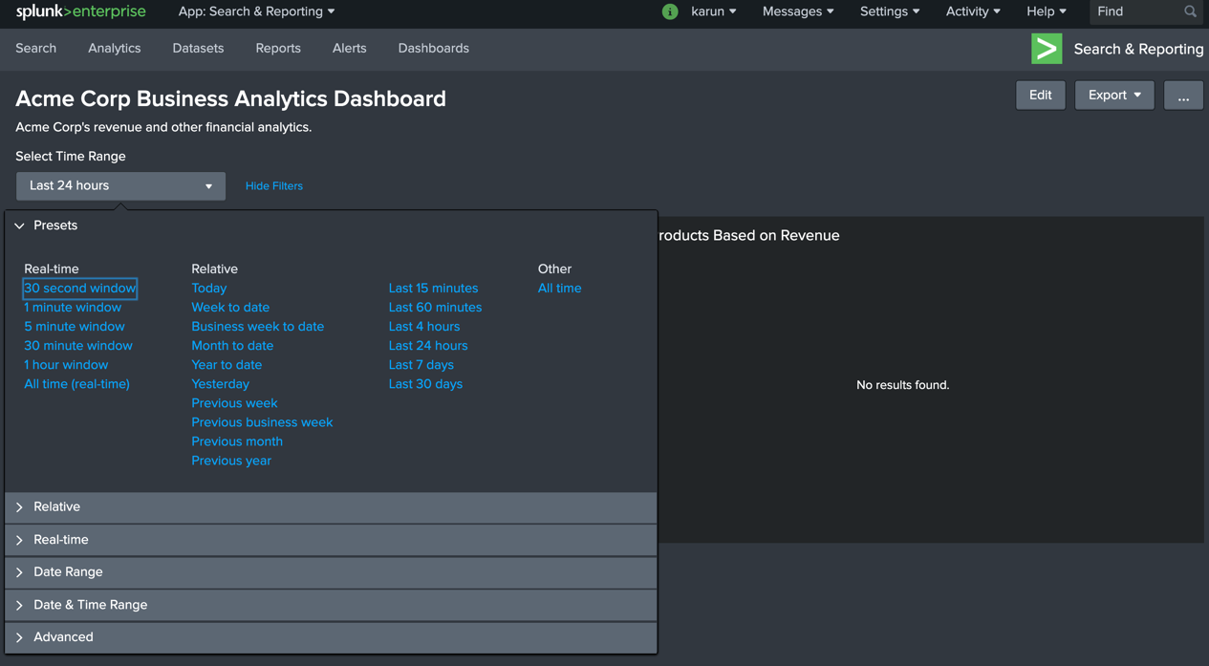

*Figure 10-28. Selecting the time range using Time Input*

Great going. In the next section, let us add a drop-down input so that user can choose an option from the drop-down list. This can be a great way to add interactivity to your dashboards.

## Adding a Drop Down Input

A drop-down input lets a user make a selection from the list of options. When an option is selected, you can capture the value of the selected option in a token. You can configure the searches in other panels of the dashboard to make use of the token value by referring to the token value using $token_name$ notation.

For example, let us build a panel that shows the trend of the revenue by product. We will use timechart command. The SPL query is as follows:

index=main sourcetype=access_combined_wcookie action=purchase

| lookup prices.csv productId OUTPUTNEW product_name,sale_price

| timechart span=6h limit=30 sum(sale_price) AS Revenue by product_name

The SPL query retrieves events with the source type access_combined_wcookie and further filters with the condition action=purchase. It then looks up prices.csv to bring in product_name and sale_price fields based on productId field. Finally, it uses timechart command to sum the sale_price every 6 hours. It uses the limit option to set the value to 20 in order to cover all the products. By default, timechart will only show 10 values and combine all other values in to OTHER. Splunk produces the visualization as shown in figure 10-29.

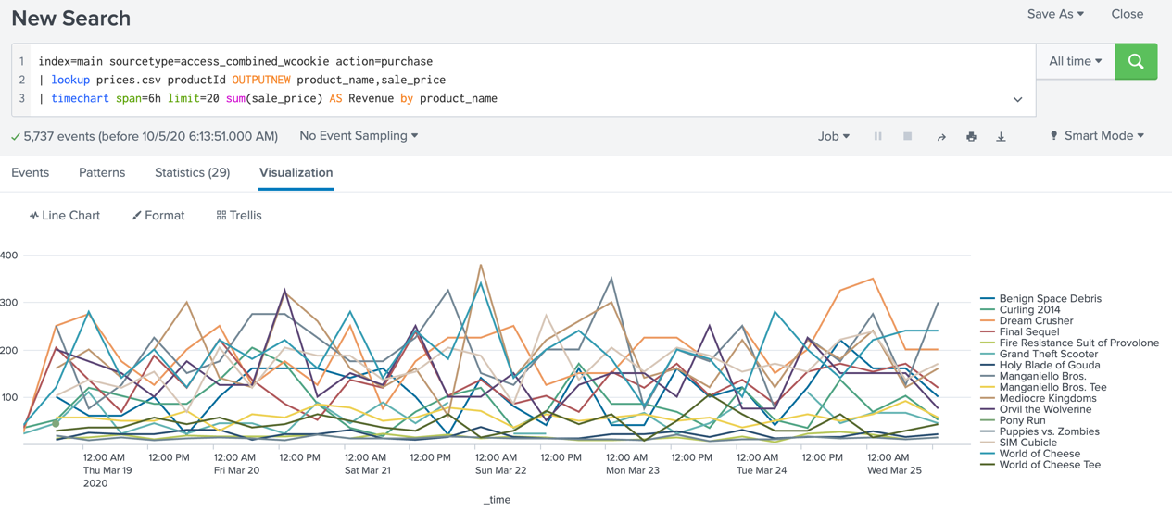

*Figure 10-29. Plotting time chart of revenue by product*

We will add this visualization into the dashboard with a drop-down input that lets a user select a product to view the trend. The drop-down list should have all the products available. The panel should automatically update based on the selection. As before, update the X axis title to Time using the format menu. Then simply click on Save As > Dashboard Panel. Provide the following values:

Dashboard: Select the existing dashboard Acme Corp Business Analytics Dashboard

Panel Title: Revenue Trend by Product

Figure 10-30 shows the Save As Dashboard panel screen.

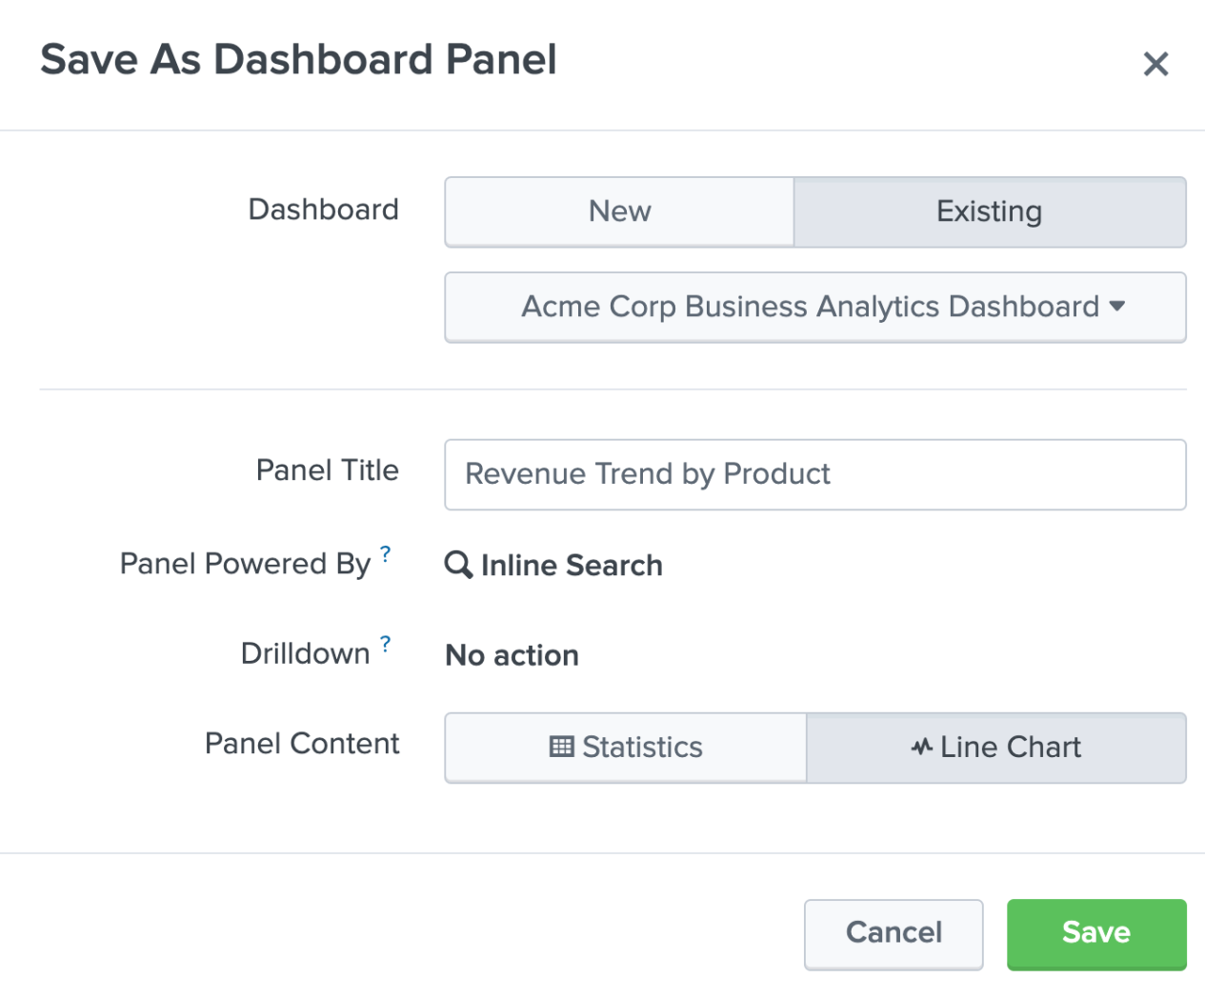

*Figure 10-30. Saving Revenue by Product as a dashboard panel*

Our dashboard now looks like figure10-31.

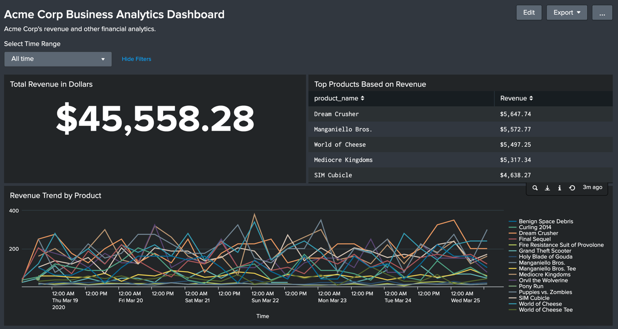

*Figure 10-31. Dashboard with three panels*

Now let us proceed to add the drop-down list. Edit the dashboard and select Add Input > Drop-down. A new drop-down input appears at the top of the dashboard. Drag this input to the Revenue Trend by Product panel. See figure 10-32.

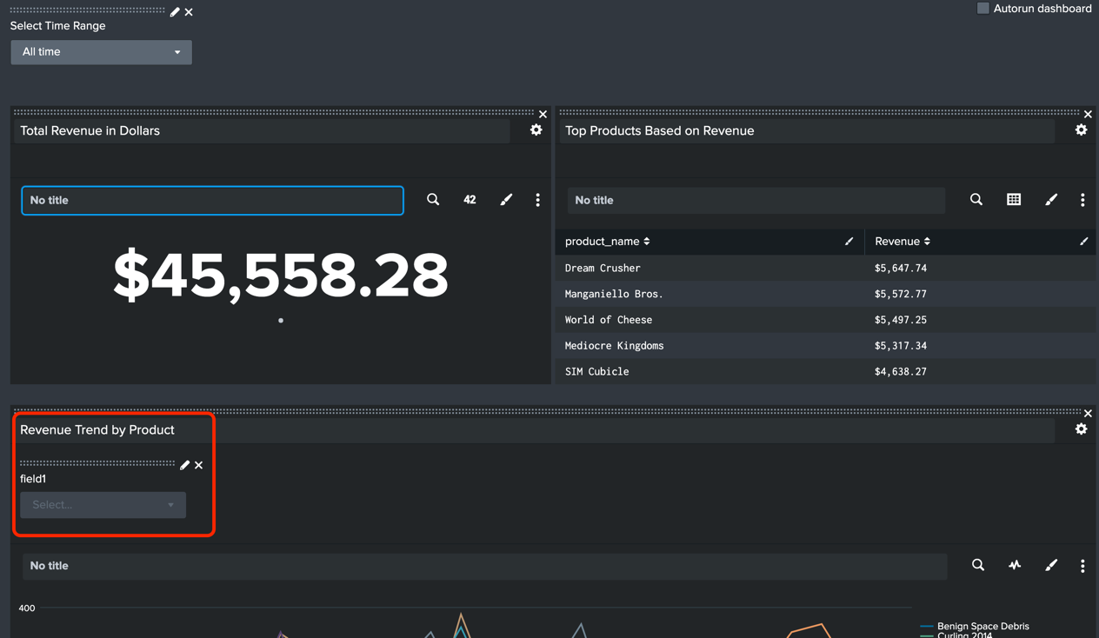

*Figure 10-32. Adding a new drop-down input.*

Click on the Pencil icon to edit the drop-down. Provide the following details:

Label: Choose Product

Search on Change: Select the check box

Token: tok_product

Scroll down to find the Static options and Dynamic options section.

### Static Options

With static options, you can provide a list of options that you manually type in. This can be useful if you already know which options to provide. In our example, we will provide one static option named ALL that will choose all products. See figure 10-33.

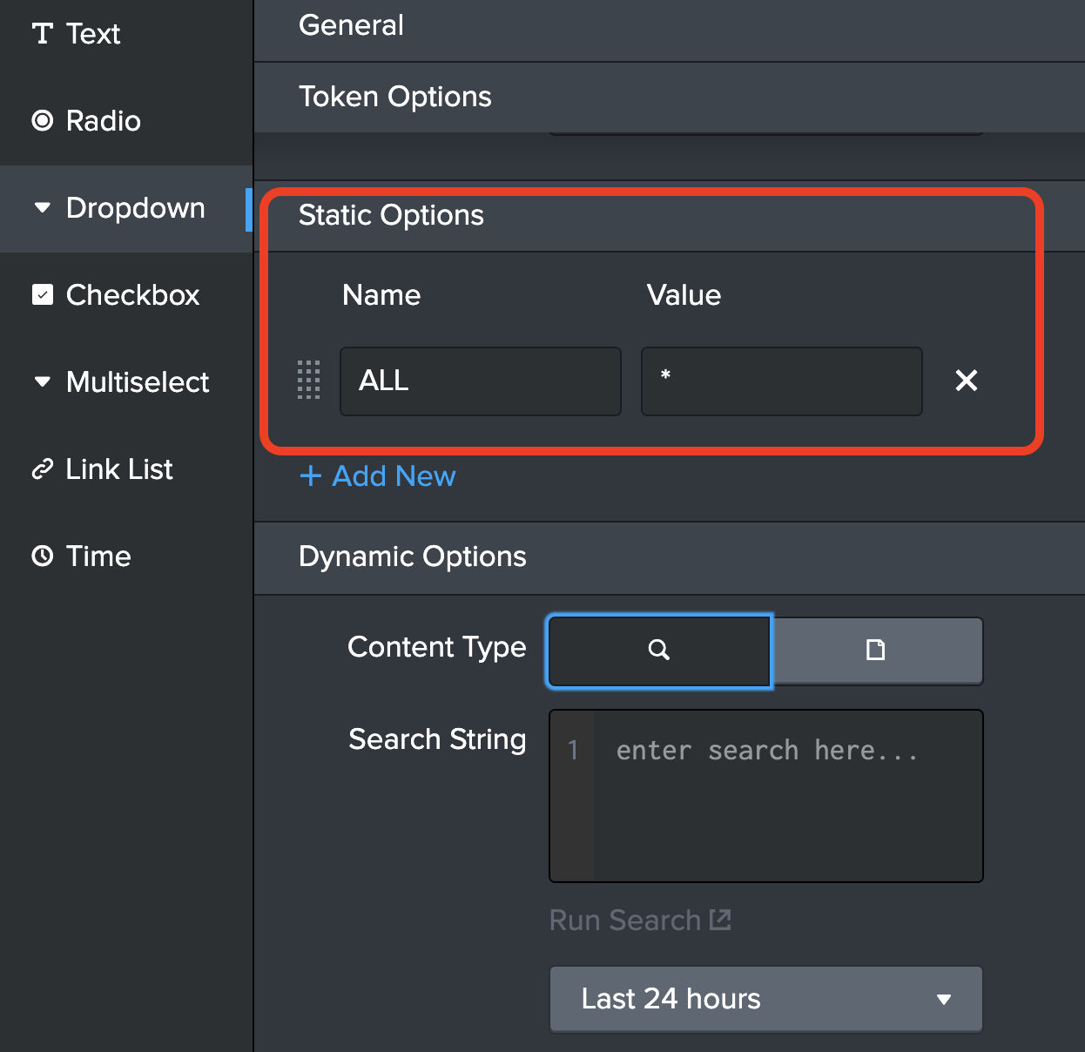

*Figure 10-33. Adding static options in drop-down input.*

The Name is the label that will show up in the drop-down list as option to select. The Value is the value that will be assigned to the token. In this case, the value * will be assigned to the token.

### Dynamic Options

While static options are useful, in most circumstances you would want to dynamically generate the drop-down options. You can do this by using the results of the search as the drop-down options. First, you need to come up with the search that lists the options you want to show in the drop-down. In our example, we'll use the following search:

| inputlookup prices.csv

| table product_name

The SPL query retrieves the content of the lookup table prices.csv by using the inputlookup command. It then filters the data using the table command. The partial output is shown below:

product_name

-------------------

Mediocre Kingdoms

Dream Crusher

Final Sequel

World of Cheese

World of Cheese Tee

Puppies vs. Zombies

...

...

In the Dynamic Options section, enter the SPL query in the Search String field. In the Field For Label field, enter product_name. This is the field returned from the search results to use as the drop-down option label. In the Field For Value field, enter product_name again. This is the field returned from the search results to use as drop-down option value. This is the value that gets passed to the token. Click Apply. See figure 10-34.

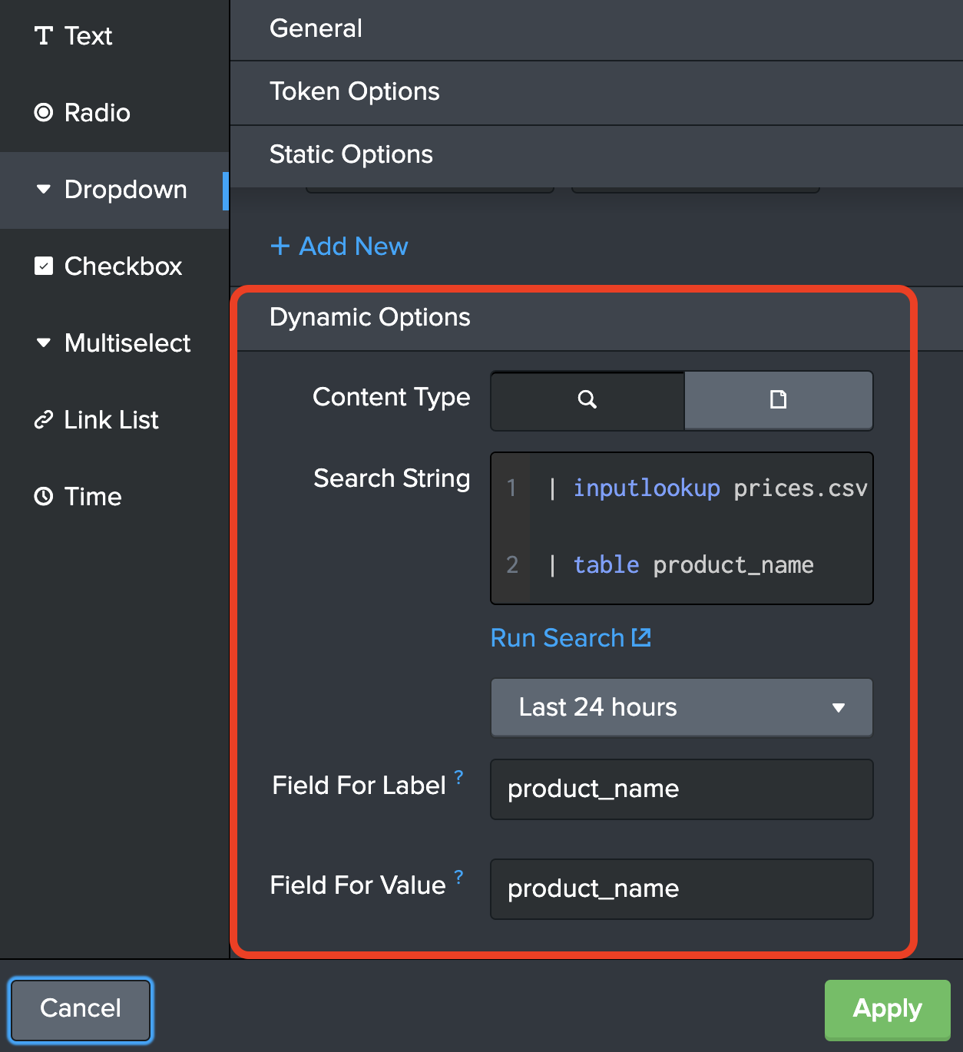

*Figure 10-34. Adding dynamic options in drop-down input.*

Now, you can verify the contents of the drop-down list by clicking on the Select drop-down. See figure 10-35.

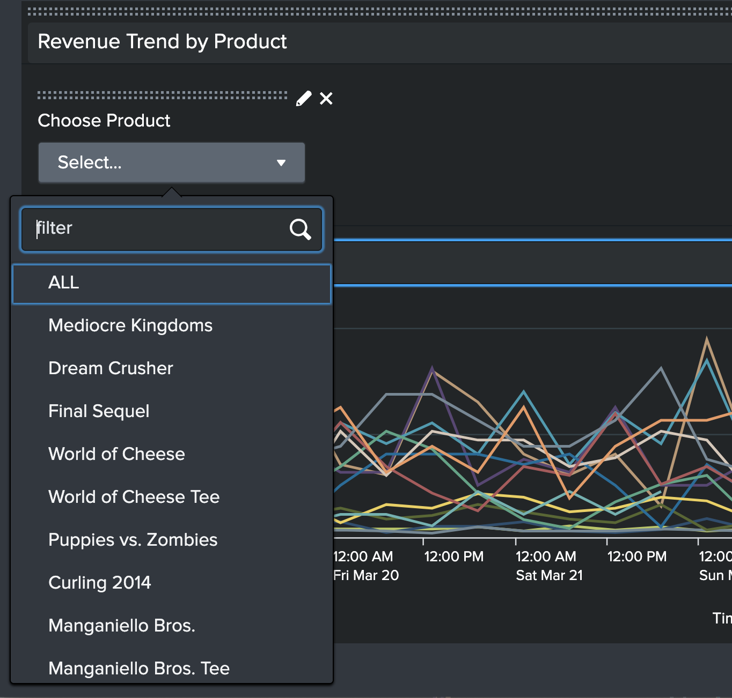

*Figure 10-35. Verifying the drop-down list options.*

Once you verify the options, edit the drop-down again to select a default value. In our example, let's use the static option ALL as the default value. This is the option that will show by default when the dashboard loads. See figure 10-36.

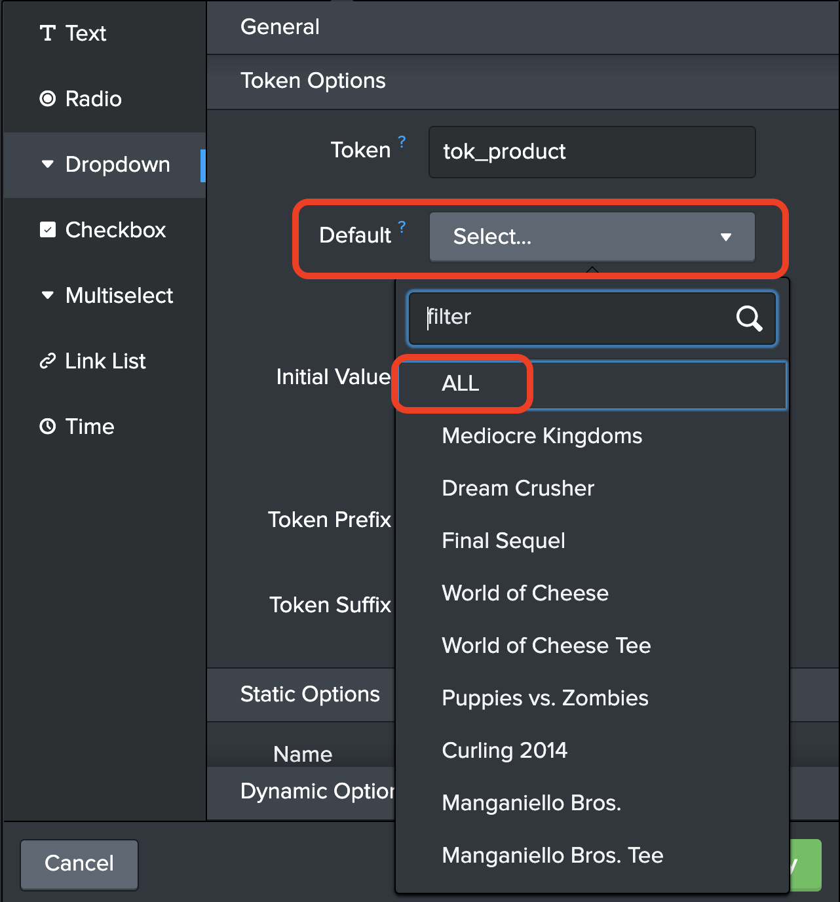

*Figure 10-38. Selecting the default option in a drop-down input.*

Now all that is left is to update the target panel (Revenue Trend by Product) to use the token.

### Updating the Target Panel to Use the Token

Merely creating the drop-down input does not enable the panels to make use of it. We need to update the search that is powering the panel. Click on the Search icon on the Revenue Trend by Product panel and edit the search. Edit the search string by adding a new filter criterion as follows:

index=main sourcetype=access_combined_wcookie action=purchase

| lookup prices.csv productId OUTPUTNEW product_name,sale_price

**| search product_name = “$tok_product$”**

| timechart span=6h limit=20 sum(sale_price) AS Revenue by product_name

As you can see, we are adding a new search filter by restricting the output to the selected product. The string $tok_product$ represents the value of the token tok_product. Note the double quotes surrounding the token. This is required to ensure that the token values with spaces in them will be surrounded by double quotes in the resulting search string. Also select the Time Range to Shared Time Picker (tok_time). See figure 10-39.

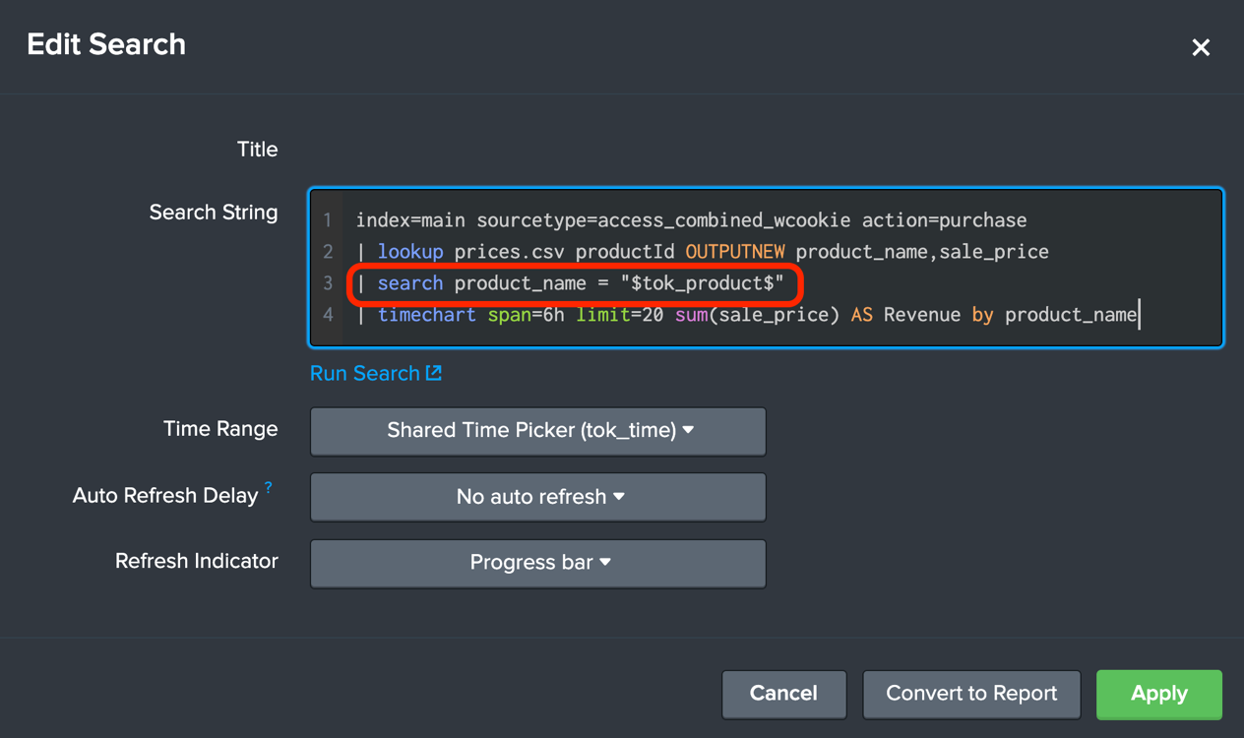

*Figure 10-39. Utilizing the token value in search string*

Click Apply and Click Save to save the dashboard. Reload the dashboard.

**Note** Always reload the dashboard when you make changes to it. Many features of dashboard visualization take effect only when it is reloaded. You can simply refresh the browser window to reload the dashboard.

Our dashboard now looks like figure 10-40.

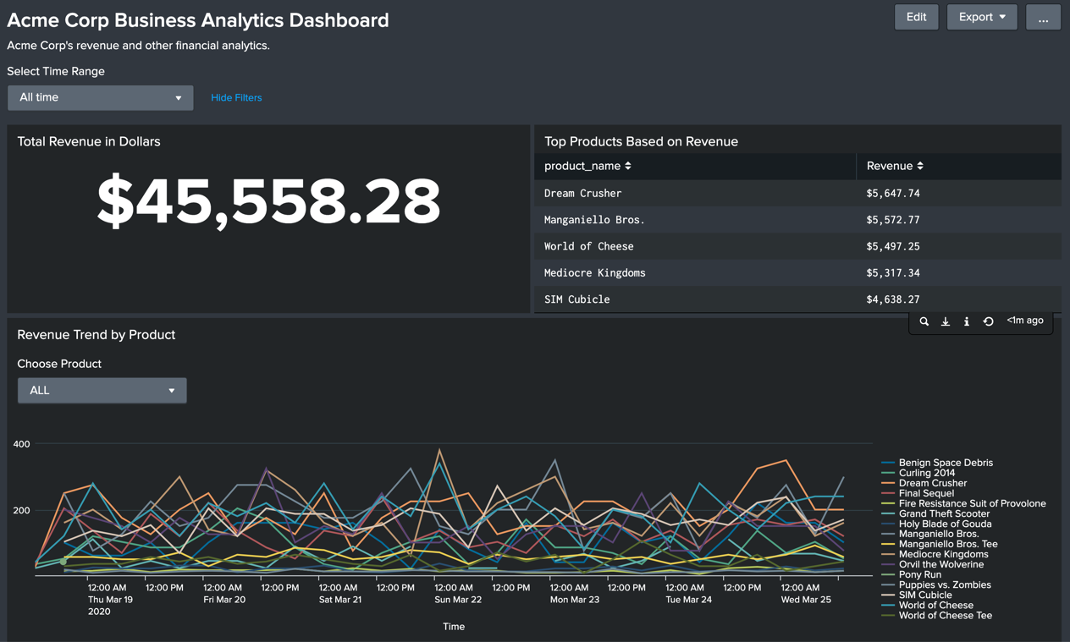

*Figure 10-40. Dashboard with drop-down input*

Note that since we chose ALL as the default value, all products are shown. Go ahead and select any of the products from the drop-down list. The panel will instantly reload the data for the product you chose. See figure 10-41.

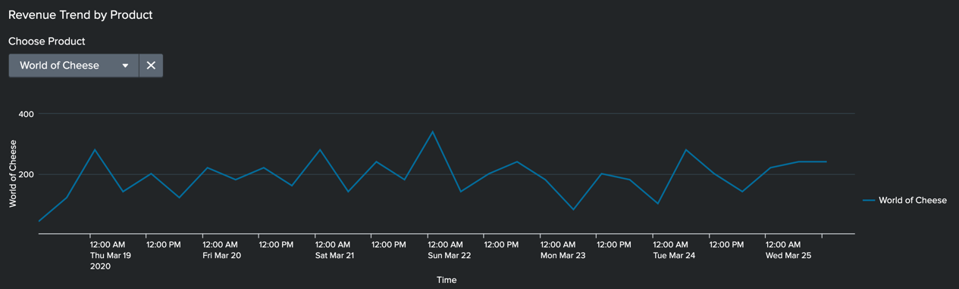

*Figure 10-41. Selecting an option from drop-down input*

If the data does not load as expected, you can review the search generated by the panel by clicking on the search icon to open the search in a new window. See figure 10-42.

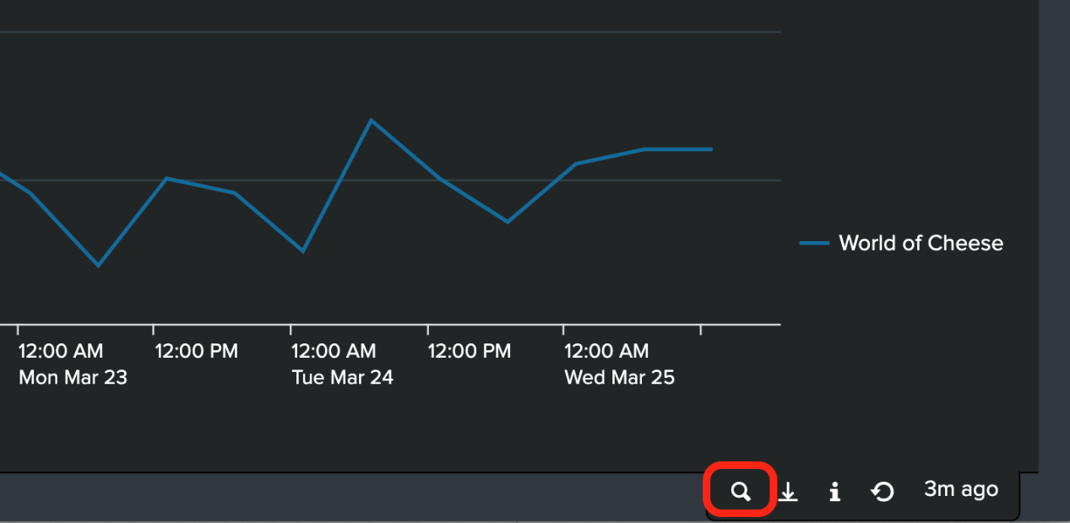

*Figure 10-41. Reviewing the search generated by a panel*

Nice job. You have learned how to add interactivity to your dashboards by using drop-down input. In similar fashion, you can add other inputs such as radio buttons and multi-select. In the next section, let's learn how to add drilldown capabilities to your dashboards.

# Creating Drilldowns

Adding drilldown capability to your dashboards can greatly enhance the interactivity and user experience. Using drilldowns, you can click on an area of a panel to display other detailed relevant data. You can perform the following actions using drilldowns:

1. Run a secondary search
2. Open another dashboard or report
3. Launch an external website (custom url)
4. Update values of tokens that can produce changes in other panels in the same dashboard

When a drilldown is invoked by clicking on an area of a panel, Spunk makes many predefined tokens available for the target. In this way, values from source panel (where the user clicks) can be passed to target panel (which is invoked as a result of drilling down).

## Tokens Available for Drilldown

The tokens have slightly different meaning depending on the type of source panel. There are two major categories of panels: Charts and Tables. The following section describes the tokens available in each category.

### Chart

Here are the predefined tokens and their descriptions in a chart visualization.

#### $click.name$

This token will carry the X-axis field or category name for the clicked location. If the chart is timechart, this token will carry the name "_time"

#### $click.value$

This token will carry the X-axis field or category value.

#### $click.name2$

This token will carry the Y-axis field or category name for the clicked location. For example, if you have multiple series plotted in a timechart, this token will carry the name of the series that was clicked.

#### $click.value2$

This token will carry the Y-axis field or category value.

#### $row.<fieldname>$

By specifying the field name, you can access any Y axis field value corresponding to the location in X axis. This token gives more fine-grained control over what to send to the target panel.

Now let's take a look at what these tokens mean in tables.

### Table

Here are the predefined tokens and their descriptions in a table visualization.

#### $click.name$

This token will carry the left most field name (the column name).

#### $click.value$

This token will carry the left most field value (column) in the clicked row.

#### $click.name2$

This token will carry the field name of the clicked cell.

#### $click.value2$

This token will carry the field value of the clicked cell.

#### $row.<fieldname>$

This token lets us access any field value (column) from the clicked row. For example, to get to the product name of any row, use $row.product_name$.

Now, let us build our dashboard to demonstrate some of the drilldown capabilities.

## Drilldown to a Secondary Search

In this drilldown, you can invoke a secondary search based on where the user clicked on the source panel. In order to enable drilldown, you would edit the dashboard and click on the Edit Drilldown menu under the More actions button (the three vertical dots). See figure 10-42.

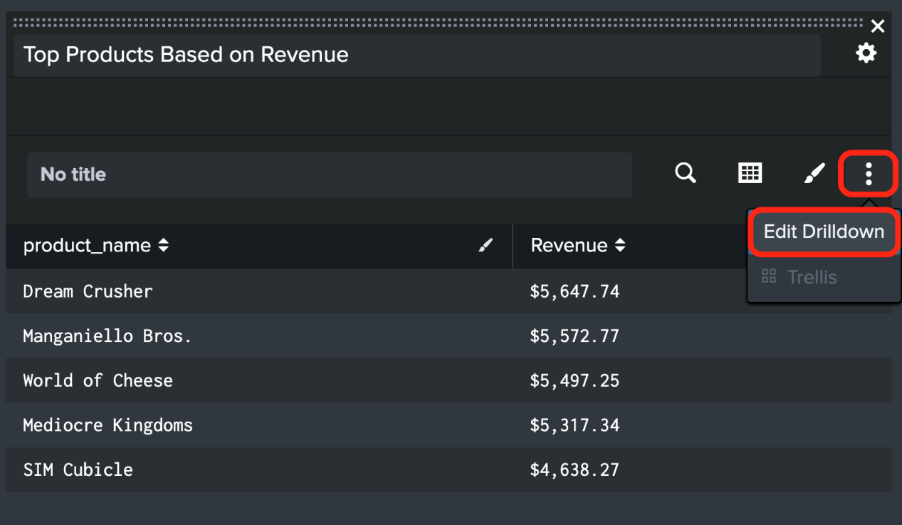

*Figure 10-42. Invoking the drilldown editor*

For this example, let us invoke a secondary search that shows all the purchases for the product that user clicked. In the Drilldown Editor, select Link to search. See figure 10-43.

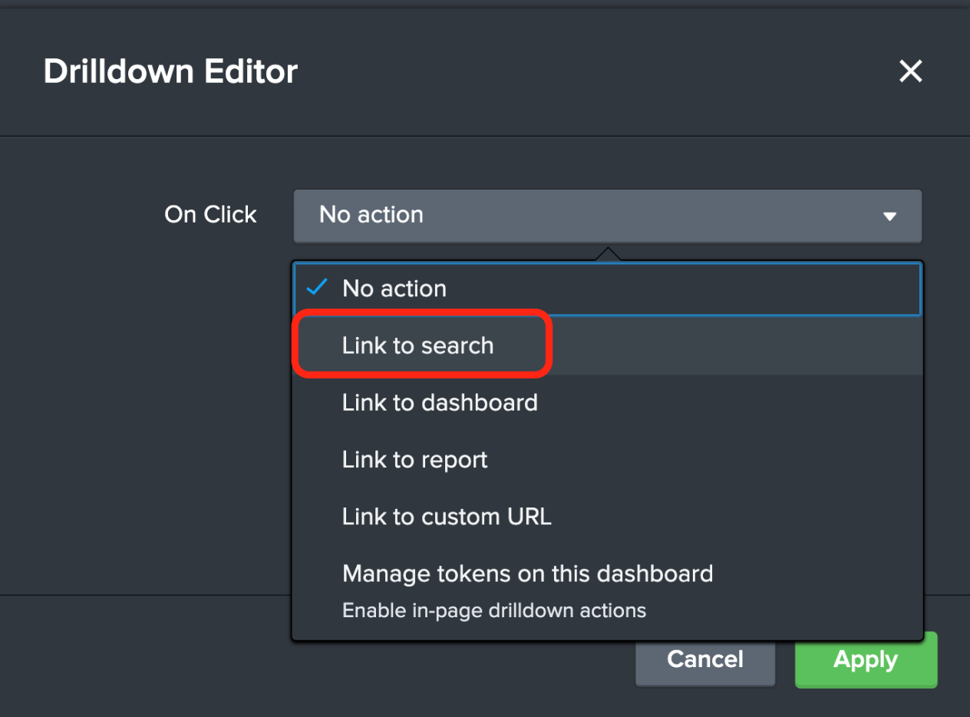

*Figure 10-43. Linking to a search in Drilldown Editor*

Choose Custom and include the following search string:

index=main sourcetype=access_combined_wcookie action=purchase

| lookup prices.csv productId OUTPUTNEW product_name,sale_price

**| search product_name = "$row.product_name$"**

| table _time,clientip,productId,product_name,sale_price

The SPL query retrieves all purchase events and filters them using the product_name field. It utilizes $row.product_name$ token. This token will carry the value of the product name from the row clicked by the user. See figure 10-44.

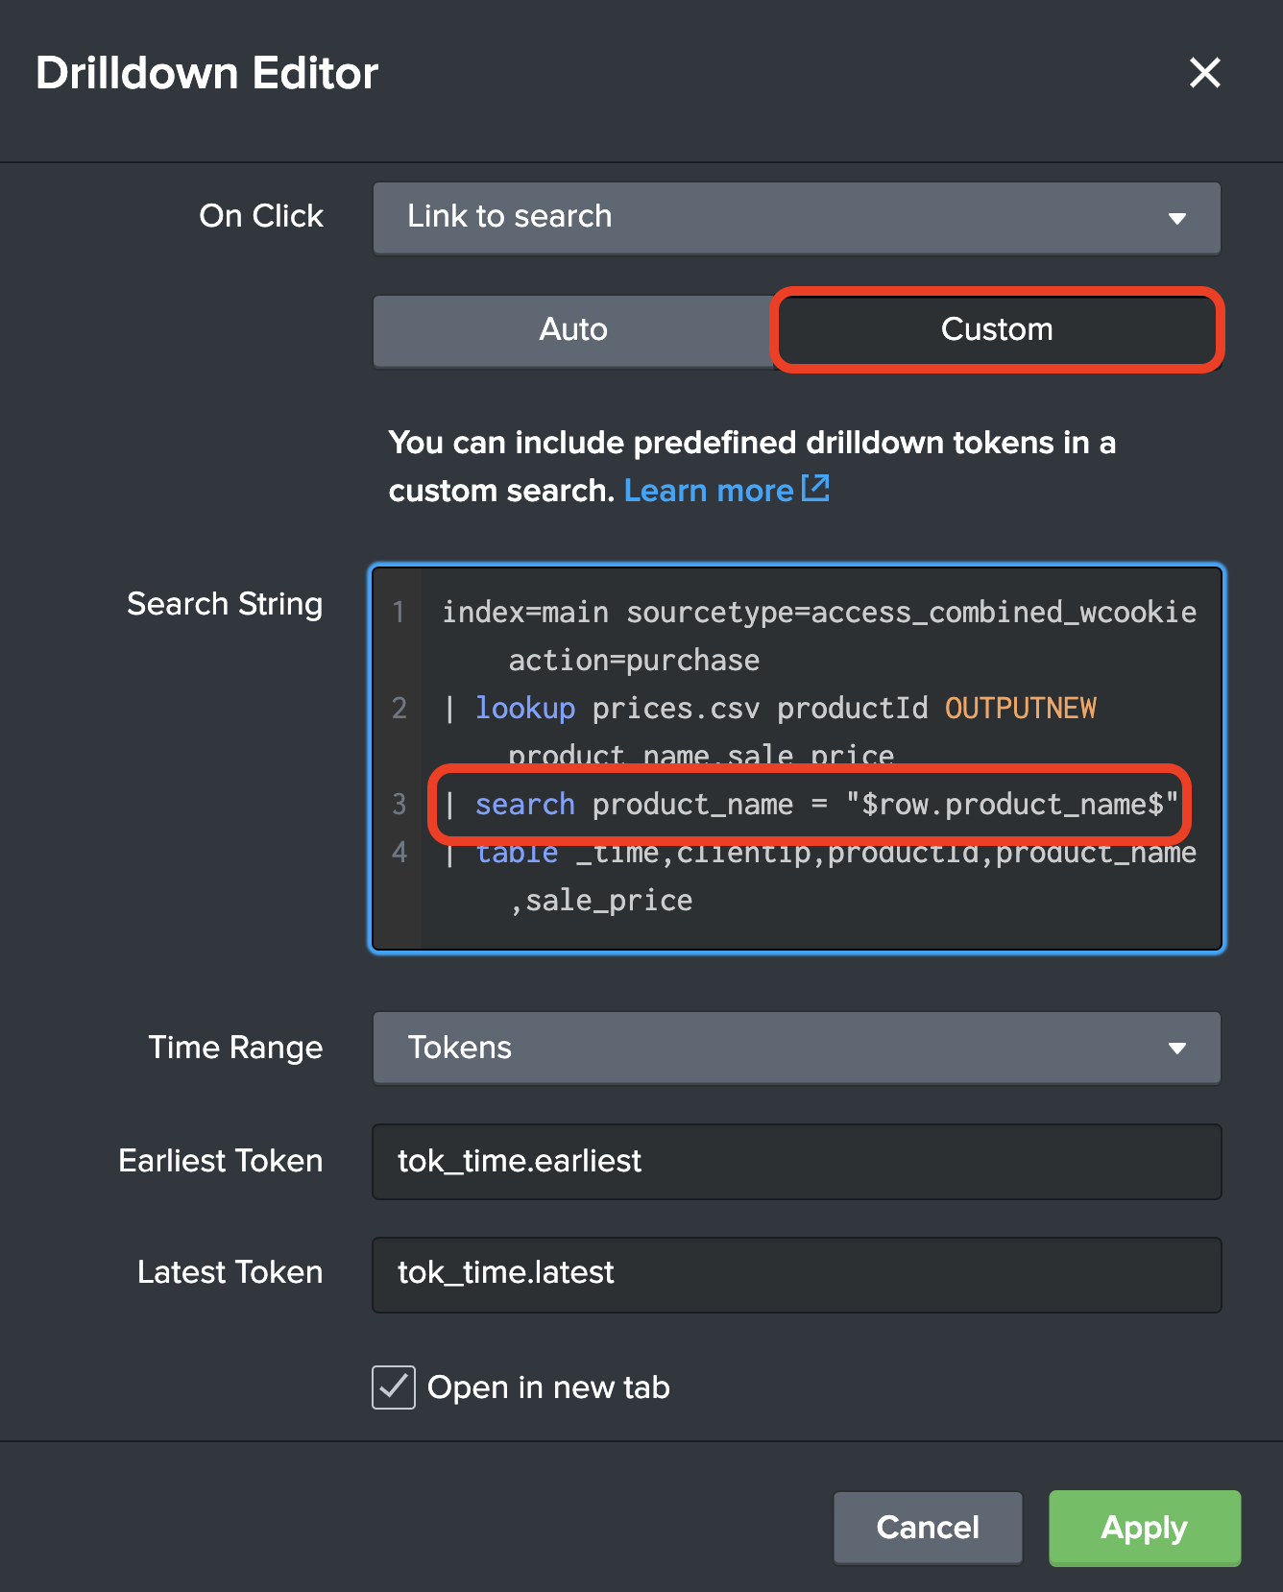

*Figure 10-44. Configuring a custom search string in Drilldown Editor*

Click Apply and save the dashboard. Notice how the dashboard now shows the table contents in blue color, indicating that they can be clicked. Upon clicking on any row within the table, you will be taken to a secondary search page where all purchase events for the product name are displayed. See figure 10-45.

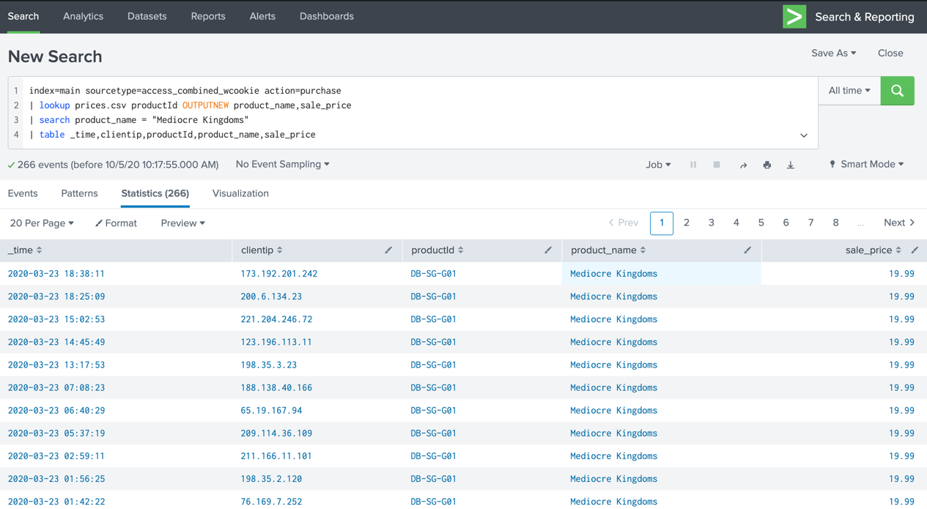

*Figure 10-45. Drilldown page that shows details of product purchases*

Now, let us build another drilldown that will create contextual changes within the dashboard.

## Showing and Hiding Panels

When a user clicks on a visualization, you can set or unset a token. By referencing this token elsewhere in the dashboard, you can make dynamic changes to the dashboard. For example, when the user clicks on the Total Revenue in Dollars single value visualization, you can show a daily revenue panel by product name in a stacked column chart. By default, we won't display this panel. Only when a user clicks on the Total Revenue, this panel should display. And when the user clicks on the newly displayed panel, it should be configured to disappear. In order to hide and display panels, we will use the depends attribute of a panel. Also, in order to configure this functionality, you must edit the Simple XML code of the dashboard.

### About Simple XML

Simple XML is the markup Splunk uses to configure and layout dashboards. All dashboards can be modified using the Simple XML code via the Simple XML Code Editor. For most configurations, Drilldown Editor is sufficient which provides a GUI to configure drilldown. However, for configuring conditional drilldowns and contextual changes (like the one we are working on), we will need to edit the Simple XML code.

### Configuring Drilldown for Contextual Changes

First, we’ll come up with the visualization for the target panel. Let’s use the following SPL query:

index=main sourcetype=access_combined_wcookie action=purchase

| lookup prices.csv productId OUTPUTNEW product_name,sale_price

| timechart span=1d sum(sale_price) AS Revenue by product_name

The SPL query retrieves all purchase events, calculates the daily revenue and plots them in a timechart. Using stacked mode of column chart format option, the following visualization is produced. See figure 10-46.

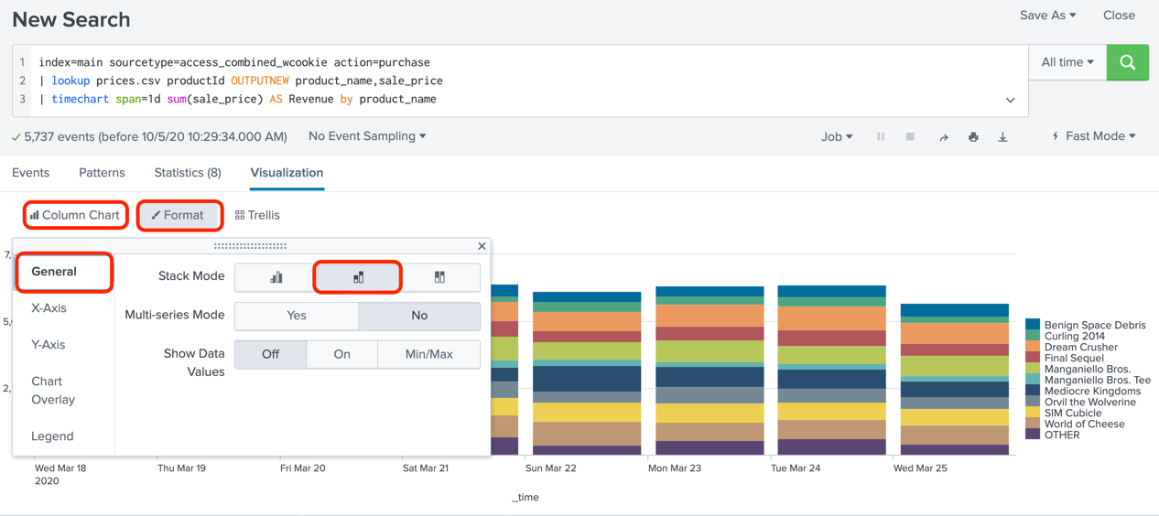

*Figure 10-46. Creating a stacked column chart*

Add this visualization to our dashboard and drag it up to place under the Total Revenue. See figure 10-47.

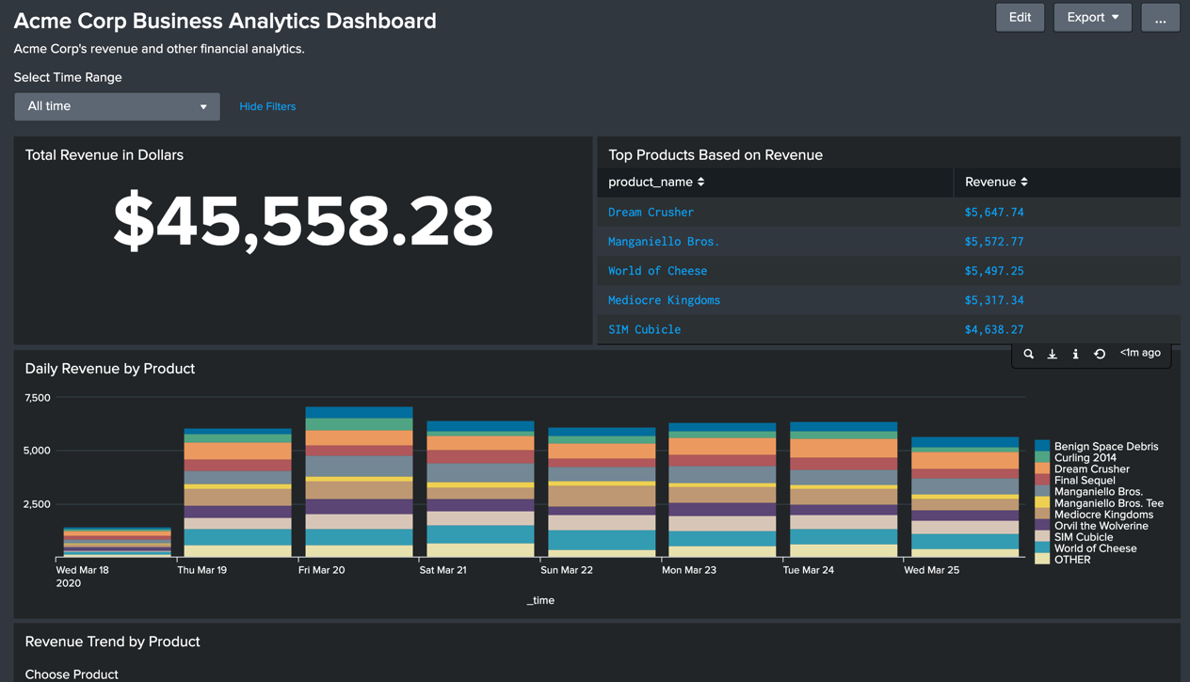

*Figure 10-47. Dashboard with stacked column chart*

Now, let us edit the Simple XML code. First, we'll work on the source panel. In order to invoke the Simple XML code editor, Edit the dashboard and click on the Source button. See figure 10-48.

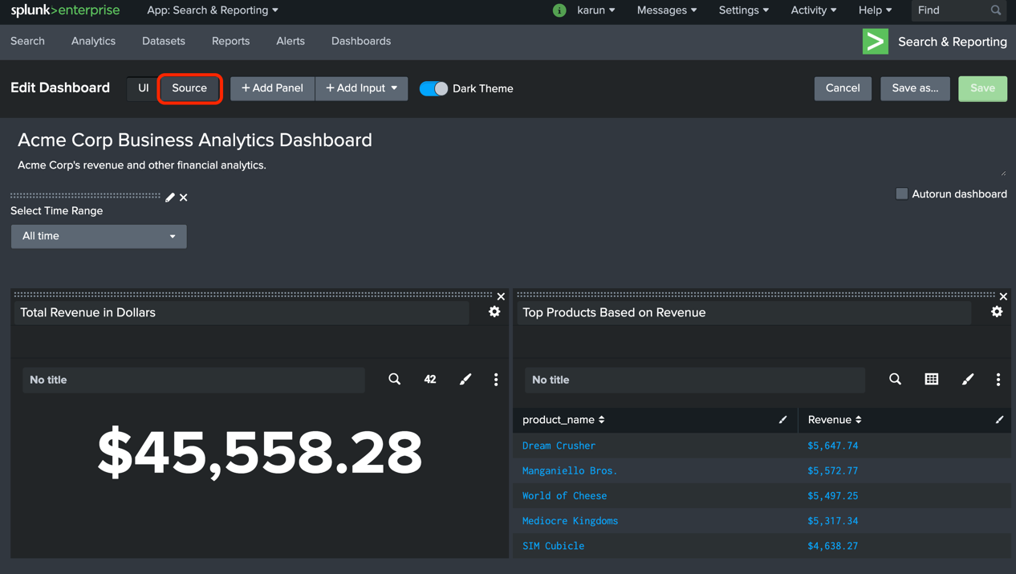

*Figure 10-47. Invoking the Simple XML code editor*

In Simple XML code editor, locate the panel with title Total Revenue in Dollars. Add the following drilldown element under the option element.

...

...

<option name="useColors">1</option>

<option name="useThousandSeparators">0</option>

**<drilldown>**

**<set token="showDetailsPanel">true</set>**

**</drilldown>**

</single>

</panel>

The Simple XML code will set the token showDetailsPanel to be true. We will use this token in the target panel.

In addition, locate the option drilldown and set it to all (by default, it is set to none). See the code below:

...

...

<option name="colorMode">none</option>

**<option name="drilldown">all</option>**

<option name="numberPrecision">0</option>

Next, locate the panel with title Daily Revenue by Product add the depends attribute in the panel.

...

...

<row>

<panel **depends="$showDetailsPanel$**">

<title>Daily Revenue by Product</title>

<chart>

The Simple XML code will make this panel display in the dashboard only when the token showDetailsPanel is set. To make the panel disappear when the user clicks anywhere in the panel, add a drilldown section as shown below:

...

...

<option name="trellis.size">medium</option>

**<drilldown>**

**<unset token="showDetailsPanel"></unset>**

**</drilldown>**

</chart>

The Simple XML code unsets the token upon a user click. This will make the panel disappear because it depends on showDetailsPanel token to be set.

In addition, locate the option charting.drilldown and set it to all (by default, it is set to none). See the code below:

<option name="charting.chart.style">shiny</option>

**<option name="charting.drilldown">all</option>**

**<option** name="charting.layout.splitSeries">0</option>

Save the code and reload the dashboard. Initially the dashboard looks like figure 10-48.

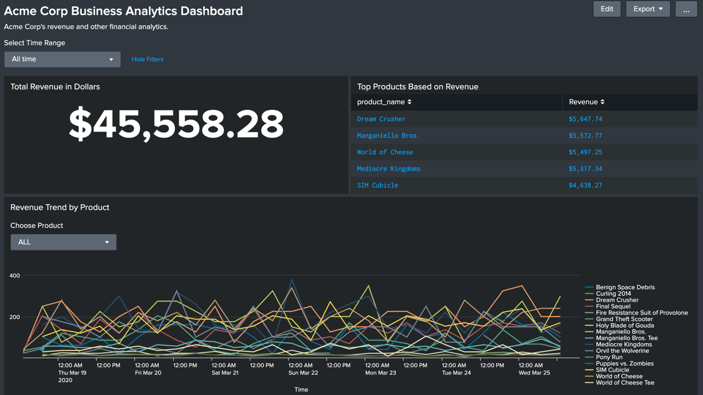

*Figure 10-48. Initial loading of a dashboard with hidden panel*

Upon clicking on the Total Revenue in Dollars dollar amount, the details panel shows up under it. See figure 10-49.

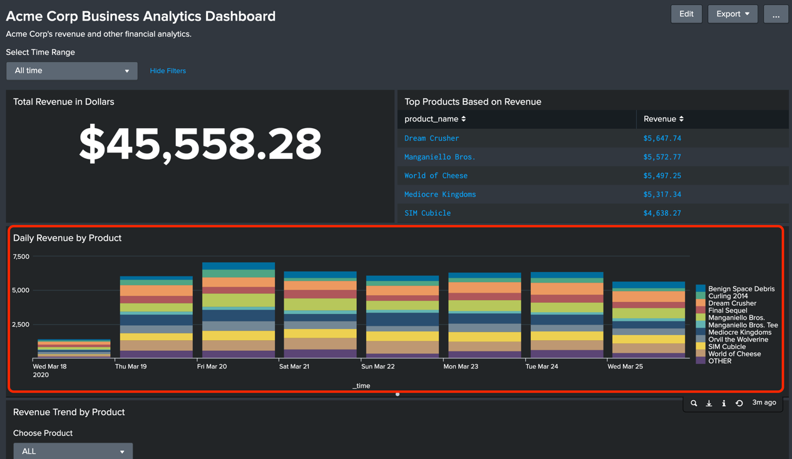

*Figure 10-49. Upon drilling down, the hidden panel is displayed*

When you click anywhere in the new Daily Revenue by Product panel, the panel disappears.

Now that you have learned how to configure drilldowns to make your dashboard interactive, let us move on to the next section where we'll learn about configuring alerts.

# Creating Alerts

Splunk alerts provide a way to trigger an action by monitoring your machine data. It can be extremely valuable to prevent an outage to your service. For example, the on-call engineer can be paged when the memory utilization of your application goes above a threshold. Splunk can be configured to take varieties of actions when the threshold is breached. In addition, you can create your own custom action.

Alerts are essentially scheduled searches that contain a threshold and action to take when the threshold is breached. To demonstrate alerts, let us build an alert using Splunk tutorial data. We will create an alert that emails the support group when the number of HTTP Server errors (500 series errors) goes beyond a certain threshold.

## Creating the Search

First, we need to come up with the SPL query that we'll use to monitor the 500 series errors. We'll use the following SPL query:

index=main sourcetype=access_combined_wcookie status = 5*

| stats count

The SPL query retrieves the events that have status field starting with the number 5. This will cover all 500 series errors such as 500,501,502 and so on. When the timeframe is set to All Time, Splunk produces the following output:

count

-----

2165

In practice, you will use more appropriate time frame such as 60 minutes. This means that the output of the SPL will show the number of 500 series errors in the past 1 hour. If you need faster alert time frame, you can go to 30 or 15 minutes.

Once the results are loaded, click on Save As > Alert at the top right. See figure 10-50.

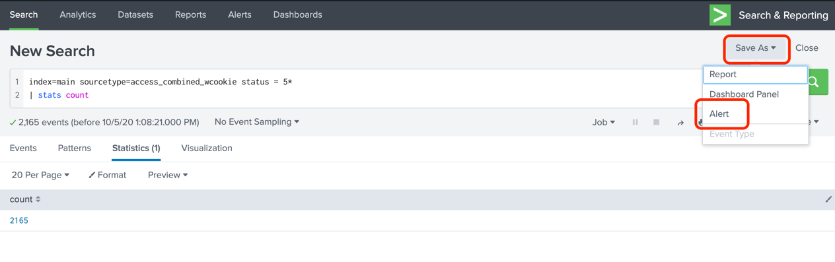

*Figure 10-50. Saving a search as Alert*

In the Save As Alert screen, provide the following details:

Title: Acme Web Server HTTP 500 Errors

Description: This alert will trigger if the number of HTTP 500 errors (as found in the access logs) go above 1000 over the past 60 minutes.

Alert Type: Scheduled

For Scheduling, I recommend using cron Schedule instead of choosing a time from the drop down. With cron scheduling, you will have the maximum flexibility in choosing the time. To run this alert at 2-minute past ever hour, we will use the expression 2 * * * *.

Time Range: Choose a meaningful range. For this example, I've chosen All Time because we are using Splunk tutorial data. In practice, you will rarely choose All Time. Since we are scheduling this alert to run on hourly basis, a time range of 60 minutes makes sense.

**Caution** In large production environments, selecting All Time can have severe performance impact.

Trigger Condition: Instead of choosing the number of results as the trigger condition, I recommend choosing custom and provide a search string to determine if the alert should be triggered. This search will be run on the results of the Alert's search (can also be referred as base search). For this example, since the output of the search shows the count of the number of 500 errors, I can set the search string as follows:

search count > 1000

With the above search, the alert will trigger if the count field has value of more than 1000.

Trigger: Once

See figure 10-51 that shows the information we entered so far.

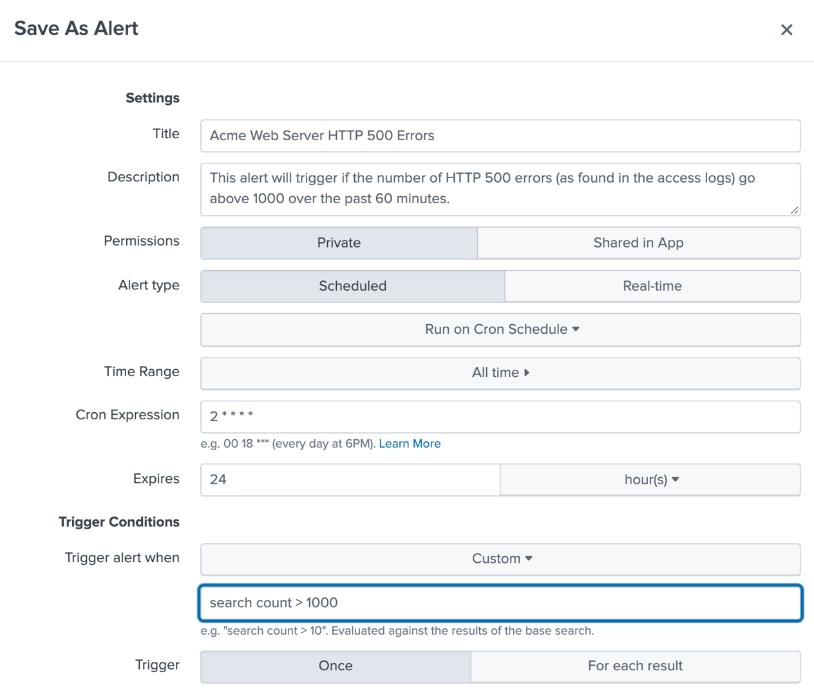

*Figure 10-51. Configuring options while saving an alert*

Now you must choose an action that must be taken when the alert is triggered. Splunk provides many actions to choose from. The most common one is the Email action. Instead, you can send the payload of the alert to a specific URL using the webhook action. For this example, let's use Email action. See figure 10-52.

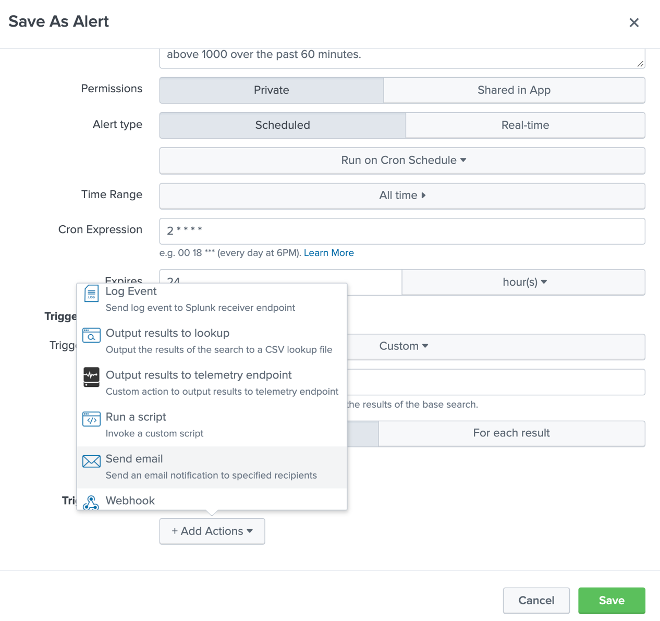

*Figure 10-52. Selecting Email action for an alert.*

**Caution** Your Splunk Server must be configured with valid SMTP configuration in order to send emails. Contact your Splunk Administrator for assistance.

In the Send Email screen, you can provide additional details to construct the email. Note that you can include a PDF of the alert results which may be useful. You can also choose to include the search string used by the alert. See figure 10-53.

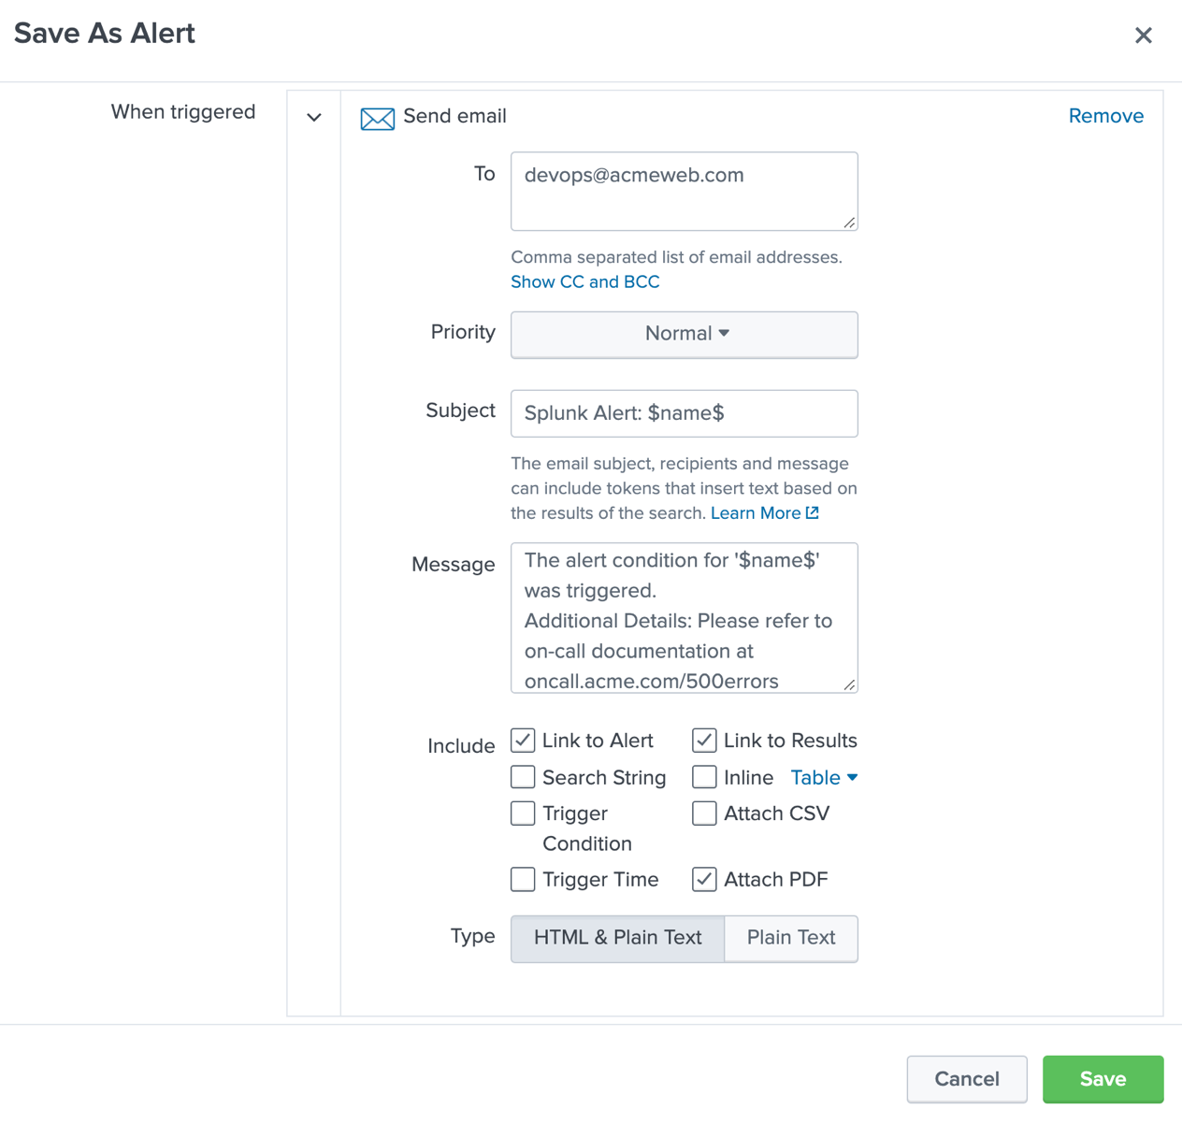

*Figure 10-53. Configuring Email action for an alert.*

Click Save. Congratulations. You have successfully created an Alert in Splunk.

**Tip** Always include detailed description in the alert message. For example, you can include a description of the Alert, where to find additional information and an on-call phone number, if applicable.

In addition to using pre-built actions, you can also create your own custom action by using Splunk custom action framework. You can find more details about custom actions at https://docs.splunk.com/Documentation/Splunk/latest/AdvancedDev/ModAlertsIntro .

That brings us to the end of this chapter. Here are the key takeaways from this chapter.

# Key Takeaways

In this chapter, you've learned how to create interactive Splunk dashboards and Alerts. These are extremely useful knowledge objects that will add immense value to your organization. Splunk dashboards can be a great way to share information with others. Dashboards are made up of panels which are powered by search results. Splunk can also trigger alerts based on search results and a threshold you specify. Let's take a look at the key takeaways from this chapter.

1. A Splunk dashboard can be created by simply running a search and choosing Save As > Dashboard panel in the search interface.
2. A Dashboard panel can be powered by in-line search, saved search (report), scheduled search, pre-built panel or a pivot.
3. For best performance, use a scheduled search to power the dashboard panels. The data displayed will be the result of the latest run of the scheduled search.
4. Using Dashboard editor, you can drag the panels to create the layout you desire.
5. The visualizations can be formatted using Dashboard editor or using Simple XML code.
6. You can add interactivity to your dashboards by adding input panels such as Time picker and drop-down input
7. Tokens are similar to variables in high-level languages that you can set and retrieve in Splunk dashboards.
8. You can configure drilldown to launch a new secondary search, a dashboard, an external URL, or contextual changes within the dashboard.
9. You can configure Splunk alerts to trigger based on search results and a threshold set by you.
10. Splunk provides many pre-built actions that can be executed upon triggering of an alert. This includes emailing and sending the alert payload to an external website.

Great going! By learning how to create Splunk dashboards and alerts, you can make the best use of the Splunk platform to suit your needs. We have just scratched the surface on these capabilities. Please refer to Splunk documentation at docs.splunk.com to learn more about them.